LABORATORY MANUAL
Electronic devices & circuits
II B.TECH -I Semester (ECE)

AY-2018-2019
DEPARTMENT OF ECE
MARRI LAXMAN REDDY INSTITUTE OF TECHNOLOGY & MANAGEMENT

MARRI EDUCATIONAL SOCIETY’S GROUP OF INSTITUTIONS
MLR INSTITUTE OF TECHNOLOGY & MANAGEMENT
(Approved by AICTE, New Delhi & Affiliated JNTU, Hyderabad)
Dundigal, Quthbullapur (M), Hyderabad – 43

(53606)ELECTRONIC DEVICES AND

CERTIFICATE

This is to certify that this manual is a bonafide record of practical work in the Electronic Devices and Circuits in First Semester of II yearB.Tech (ECE) programme during the academic year 2018-19. This book is prepared by M rs.K.S.Monica(Asst.Professor), Mrs.S.K.HimaBind(Asst.Professor), Mrs.S.Sindhu Rekha(Assistant Professor)Department of Electronics and Communication Engineering.

INDEX
S.No | Content | Page No:
 | Preface
 | Acknowledgement
 | General Instructions
 | Safety Precautions
 | Institute Vision and Mission
Department Vision,Mission, Programme Educational Objectives and Specific
Outcomes
 | Programme Outcomes
 | Course Structure, Objectives &Outcomes
 | Experiments Learning Outcomes
1 | Identification, Specification, Testing of R,L,C Components (Color Codes), Potentiometers, Switches (SPDT,DPDT, and DIP),Coils, Gang Condensers, Relays, Bread Boards, PCB’s
2 | Identification, Specification, Testing of Active Devices, Diodes, BJT’s Low Power JFET’s MOSFET’s Power Transistors, LED’s LCD’s, SCR, UJT.
3 | Study and Operation of Multimeters (Analog and Digital)Function Generator,Regulated Power Supplies,CRO.
4 | Forward and Reverse Bias V-I Characteristics of PN Junction Diode. | 13
5 | Zener Diode V-I Characteristics and Zener as Voltage Regulator | 18
6 | Half Wave Rectifier with & without Filters. | 23
7 | full Wave Rectifier with & without Filters.. | 29
8 | Input And Output Characteristics of a BJT in CE configuration and calculation of h-parameters. | 34
9 | Input And Output Characteristics of a BJT in CB configuration and calculation of h-parameters. | 41
10 | FET Characteristics in CS Configuration | 49
11 | Design of self bias circuit | 56
12 | Frequency Response of CE Amplifier | 59
13 | Frequency Response of CC Amplifier | 65
14 | Frequency Response of Common Source FET Amplifier | 70
15 | SCR Characteristics | 75
16 | UJT Characteristics | 80

PREFACE

This laboratory lays the foundation for the Electronics and Communication Engineering students during second year of their course..
Circuits and components of EDC Lab can be divided into 2 groups: analog & digital. In analog lab, the students design, construct and test the working of analog circuits such as transistor amplifiers, operational amplifiers and oscillators. In digital lab, the students construct simple digital circuits such as logic gates, adders, flip-flops, counters, registers and multiplexers. After performing all the experiments included in this Laboratory, it is hoped the student receives good training to handle any electronic equipment available in electronics field.
Basic electronic equipments used in electronics laboratory
- Cathode Ray Oscilloscope to view and measure AC waveforms.
- Function Generator used to design, develop and to trouble shoot electronic equipments .
- Regulated power supply to supply DC voltage to electronic circuits.
- Breadboard to mount the components temporarily for experimental work.
- IC Trainer kits to design sequential and combinational logic circuits

By,

K.S.MONICA,
S.K.HIMABINDU,
R.SINDHU REKHA

ACKNOWLEDGEMENT

It was really a good experience, working with Electronic Devices and Circuits lab. First we would like to thank Mr.K.Naga Bhushanam, Assoc.Professor, HOD of Department of Electronics and Communication Engineering, Marri Laxman Reddy Institute of technology & Management for his concern and giving the technical support in preparing the document.
We are deeply indebted and gratefully acknowledge the constant support and valuable patronage of Dr.R.Kotaih, Director, Marri Laxman Reddy Institute of technology & Management for giving us this wonderful opportunity for preparing the Electronic Devices and Circuits laboratory manual.
We express our hearty thanks to Dr.K.Venkateswara Reddy, Principal, Marri Laxman Reddy Institute of technology & Management, for timely corrections and scholarly guidance.
At last, but not the least I would like to thanks the entire ECE Department faculty those who had inspired and helped us to achieve our goal.

By,

K.S.MONICA
S.K.HIMABINDU ,
R.SINDHU REKHA

GENERAL INSTRUCTIONS

1. Students are instructed to come to Electronic Devices and Circuits laboratory on time. Late comers are not entertained in the lab.

2. Students should be punctual to the lab. If not, the conducted experiments will not be repeated.

3. Students are expected to come prepared at home with the experiments which are going to be performed.

4. Students are instructed to display their identity cards before entering into the lab.

5. Students are instructed not to bring mobile phones to the lab.

6. Any damage/loss of equipments like transformers ,transistors, CRO’s etc., during the lab session, it is student’s responsibility and penalty or fine will be collected from the student.

7. Students should update the records and lab observation books session wise. Before leaving the lab the student should get his lab observation book signed by the faculty.

8. Students should submit the lab records by the next lab to the concerned faculty members in the staffroom for their correction and return.

9. Students should not move around the lab during the lab session.

10. If any emergency arises, the student should take the permission from faculty member concerned in written format.

11. The faculty members may suspend any student from the lab session on disciplinary grounds.

12. Never copy the output from other students. Write down your own outputs.

INSTITUTION VISION AND MISSION

VISION
To be as an ideal academic institution by graduating talented engineers to be ethically strong, competent with qualityresearch and technologies

MISSION
To fulfill the promised vision through the following strategic characteristics and aspirations:
- Utilize rigorous educational experiences to produce talented engineers
- Create an atmosphere that facilitates the success of students
- Programs that integrate global awareness, communication skills and Leadership qualities
- Education and Research partnership with institutions and industries to prepare the students for interdisciplinary research

DEPARTMENT VISION, MISSION , PROGRAMME EDUCATIONAL OBJECTIVES AND SPECIFIC OUTCOMES

Vision and Mission
Our Vision
Imparting quality technical education through research, innovation and team work for a lasting technology development in the area of Electronics and Communication Engineering.
Our Mission
To develop a strong centre of excellence for education and research with excellent infrastructure and well qualified faculties to instill in them a passion for knowledge.
To achieve the Mission the department will
- Establish a unique learning environment to enable the students to face the challenges of the Electronics and Communication Engineering field.
- Promote the establishment of centre of excellence in niche technology areas to nurture the spirit of innovation and creativity among faculty and students.
- Provide ethical and value based education by promoting activities addressing the societal needs.
- Enable students to develop skills to solve complex technological problems of current times and also provide a framework for promoting collaborative and multidisciplinary activities.

PEO's & PO's

PROGRAMME EDUCATIONAL OBJECTIVES
PEO 1: Have successful careers in Industry.
PEO 2: Show excellence in higher studies/ Research.
PEO 3: Show good competency towards Entrepreneurship.

PROGRAM OUTCOMES
a | An ability to apply knowledge of Science, Mathematics, Engineering & Computing fundamentals for the solutions of Complex Engineering problems
b | An ability to identify, formulates, research literature and analyze complex engineering problems using first principles of mathematics and engineering sciences.
c | An ability to design solutions to complex process or program to meet desired needs.
d | Ability to use research-based knowledge and research methods including design of experiments to provide valid conclusions.
e | An ability to use appropriate techniques, skills and tools necessary for computing practice.
f | Ability to apply reasoning informed by the contextual knowledge to assess social issues, consequences & responsibilities relevant to the professional engineering practice.
g | Ability to understand the impact of engineering solutions in a global, economic, environmental, and societal context with sustainability.
h | An understanding of professional, ethical, Social issues and responsibilities.
i | An ability to function as an individual, and as a member or leader in diverse teams and in multidisciplinary settings.
j | An ability to communicate effectively on complex engineering activities within the engineering community.
k | Ability to demonstrate and understanding of the engineering and management principles as a member and leader in a team.
l | Ability to engage in independent and lifelong learning in the context of technological change.

PROGRAM SPECIFIC OUTCOMES
PSO1 | Analyze and design analog & digital circuits or systems for a given specification and function.
PSO2 | Implement functional blocks of hardware-software co-designs for signal processing and communication applications.

COURSE STRUCTURE, OBJECTIVES & OUTCOMES

Laboratory subjects – Internal and external evaluation– Details of marks
Electronic Devices and Circuits lab lab will have a continuous evaluation during 3rdsemester for 25 sessional marks and 75 end semester examination marks.
Out of the 25 marks for internal evaluation, day-to-day work in the laboratory shall be evaluated for 15 marks and internal practical examination shall be evaluated for 10 marks conducted by the laboratory teacher concerned.

The end examination will be evaluated for a maximum of 75 marks.The end semester examination shall be conducted with an external examiner and internal examiner. The external examiner shall be appointed by the principal / Chief Controller of examinations

Course Objectives:
The objective of this lab is to make the students
- To understand the basic working principle of electronic devices.
- To specify various active and passive electronic components and devices and identify the terminals and to draw the symbols for different electronic components.
- To understand and operate multimeter for current, voltage and resistance measurements.
- To design electronic circuits for various applications using multisim software .
- To investigate / test / verify property or characteristics of electronic devices, amplifiers and oscillators
- To implement and verify logic gates, sequential and combinational logic circuits.
- To learn operating principle and applications of electronic circuits and devices like amplifier, oscillator, switching circuits , wave shaping circuits aSCM188156nd multivibrators.



LIST OF EXPERIMENTS:

PART A :( Only for Viva-Voce Examination)
ELETRONIC WORKSHOP PRACTICE (in 3 Lab sessions):
- Identification, Specification, Testing of R,L,C Components (Color Codes), Potentiometers, Switches (SPDT,DPDT, and DIP),Coils, Gang Condensers, Relays, Bread Boards, PCB’s
- Identification, Specification, Testing of Active Devices, Diodes, BJT’s Low Power JFET’s MOSFET’s Power Transistors, LED’s LCD’s, SCR, UJT.
- Study and Operation of
Multimeters (Analog and Digital)
Function Generator
Regulated Power Supplies
CRO.
PART B: (For Laboratory Examination- Minimum of 10 Experiments)
- Forward and Reverse Bias V-I Characteristics of PN Junction Diode.
- Zener Diode V-I Characteristics and Zener as Voltage Regulator.
- Half Wave Rectifier with & without Filters.
- full Wave Rectifier with & without Filters.
- Input And Output Characteristics of a BJT in CE configuration and calculation of h-parameters.
- Input And Output Characteristics of a BJT in CB configuration and calculation of h-parameters.
- FET Characteristics in CS Configuration.
- Design of self bias circuit.
- Frequency Response of CE Amplifier.
- Frequency Response of CC Amplifier.
- Frequency Response of Common Source FET Amplifier.
- SCR Characteristics.
- UJT Characteristics.

ELECTRONIC DEVICES & CIRCUITS LAB

LIST OF EXPERIMENTS:

The following experiments are simulated in simulation laboratory using Multisim software and also tested in the EDC/ECA Hardware lab using discrete components.

- Forward and Reverse Bias V-I Characteristics of PN Junction Diode.
- Zener Diode V-I Characteristics and Zener as Voltage Regulator.
- Half Wave Rectifier with & without Filters.
- Full Wave Rectifier with & without Filters.
- Input And Output Characteristics of a BJT in CE Configuration and calculation of h-parameters.
- Input And Output Characteristics of a BJT in CB Configuration and calculation of h-parameters.
- FET Characteristics in CS Configuration.
- Design of self bias circuit.
- Frequency Response of CE Amplifier.
- Frequency Response of CC Amplifier.
- Frequency Response of Common Source FET Amplifier.
- SCR Characteristics.
- UJT Characteristics.

EXPT NO: 1.

FORWARD & REVERSE BIAS CHARACTERSTICS OF PN JUNCTION DIODE

AIM: -
- To study the characteristics of PN junction diode under
a) Forward bias. b) Reverse bias.
- To find the cut-in voltage (Knee voltages) static & dynamic resistance in forward & reverse direction.

COMPONENTS & EQUIPMENTS REQUIRED: -

S.No | Device | Range/Rating | Qty
1. | Regulated power supply voltage | 0-30V | 1
2. | Voltmeter | 0-1V or 0-20V | 1
3. | Ammeter | 0-10mA,200mA | 1
4. | Connecting wires & bread board
5 | Diode | In4007,OA79
6 | Resistors | 1kΩ,10kΩ

THEORY:
The V-I characteristics of the diode are curve between voltage across the diode and current through the diode. When external voltage is zero, circuit is open and the potential barrier does not allow the current to flow. Therefore, the circuit current is zero. When P-type (Anode is connected to +ve terminal and n- type (cathode) is connected to –ve terminal of the supply voltage, is known as forward bias. The potential barrier is reduced when diode is in the forward biased condition. At some forward voltage, the potential barrier altogether eliminated and current
starts flowing through the diode and also in the circuit. The diode is said to be in ON state. The current increases with increasing forward voltage. When N-type (cathode) is connected to +ve terminal and P-type (Anode) is connected –ve terminal of the supply voltage is known as reverse
bias and the potential barrier across the junction increases. Therefore, the junction resistance becomes very high and a very small current (reverse saturation current) flows in the circuit. The diode is said to be in OFF state. The reverse bias current is due to minority charge carriers. The p-n junction diode conducts only in one direction.

CIRCUIT DIAGRAM:
FORWARD BIAS:-

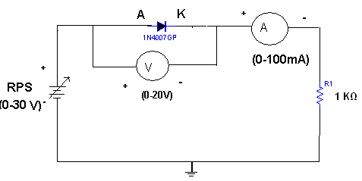

REVERSE BIAS:-
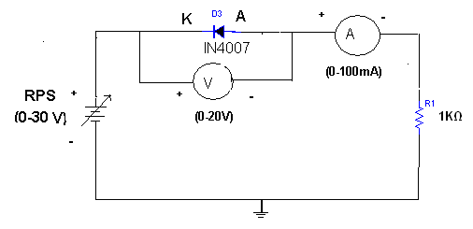

EXPECTED WAVEFORM:-
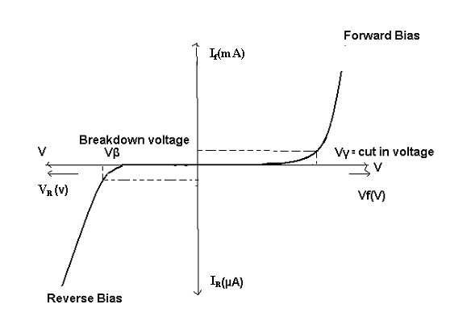
PROCEDURE: -
Forward bias characteristics
- Connect the circuit diagram as shown in figure for Forward bias using silicon diode.
- Now vary RPS supply voltage Vs in steps from 0V onwards (0.1V,0.2V……1V) note down the forward current (If) through the diode for different Forward voltages (Vf) across the diode without exceeding the rated value (If Max=20mA)
- Tabulate the results in the tabular form.
- Plot the graph between Vf & If.
- Repeat the above steps 4 steps by using Germanium diode.

Reverse bias characteristics
- Connect the circuit diagram as shown in figure for Reverse bias using silicon diode.
- Now vary RPS supply voltage Vs in steps from 0V onwards (1V,2V……10V) note down the forward current (Ir) through the diode for different Reverse voltages (Vr) across the diode without exceeding the rated value (Vr Max=15V)
- Tabulate the results in the tabular form.
- Plot the graph between Vr & Ir.
- Repeat the above steps 4 steps by using Germanium diode.

PRECAUTIONS:
- Check the wires for continuity before use.
- Keep the power supply at Zero volts before Start.
- All the contacts must be intact.

TABULAR COLUMN: Forward Bias TABULAR COLUMN: Reverse Bias
SL. No | Forward voltage (Vf) | Forward current (If)
1 | 0
2 | 0.15
3 | 0.25
4 | 0.3
5 | 0.4
6 | 0.5
7 | 0.6
8 | 0.7
9 | 0.72
10 | 0.75
SL. No | Forward voltage (Vf) | Forward current (If)
1 | 1
2 | 2
3 | 3
4 | 4
5 | 5
6 | 6
7 | 7
8 | 8
9 | 9
10 | 10

Specifications |  | Si | Ge
Cut in Voltage
Static Resistance  Dynamic Resistance | F. Bias  R. Bias  F. Bias  R. Bias

RESULT: - Forward and Reverse Bias characteristics for a p-n diode is observed

VIVA QUESTIONS:
- What is P-N junction diode?
- What is doping why doping is necessary?
- Difference between P-type and N-type semiconductor materials?
- What is diode equation?
- What is an ideal diode?
- Define depletion region of a diode?
- What is meant by transition & space charge capacitance of a diode?
- Is the V-I relationship of a diode Linear or Exponential?
- Define cut-in voltage of a diode and specify the values for Si and Ge diodes?
- What are the applications of a p-n diode?
- Draw the ideal characteristics of P-N junction diode?
- What is the diode equation?
- What is the break down voltage?
- What is the effect of temperature on PN junction diodes?
- What is PIV?
- What is Forward bias?
- What is Reverse bias?
- What is Forward voltage?
- What is Reverse current?
- What is an ideal diode?
- What is Break down voltage?
- What is cut-in volatge?
- Is the V-I relationship of a diode Linear or Exponential?
- Define diode?
- What are the characterstics of diode?
- Draw the ideal characteristics of P-N junction diode?
- What is the diode characterstics?
- What is the break down voltage in diode?
- What is the effect of PN junction diodes?
- What is PVI?
- Prove that P-N junction Diode acts as a isolator?
- Prove that P-N junction diode acts as on Switch when it is in forward bias?
- Prove that P-N junction diode acts as off Switch, when it is in Reverse bias?
- Find the change in cut-in voltage when input resistance is varied from 1k to 1M?
- Prove that Ohms law is verified for P-N junction diode in forward biased condition?
- Find the static resistance of P-N junction Diode?
- Find the Dynamic resistance of P-N junction Diode?
- Find the cut in voltage for the given diode in forward bias?
- Explain what does the arrow heads represents in the schematic symbol of PN junction diode.
- Why silicon is preferred over Germanium in the manufacture of semiconductor devices
- Name the breakdown mechanism in a lightly doped PN junction under reverse biased condition.
- Is reverse saturation current of diode is independent of reverse bias voltage.
- Why germanium is more temperature dependent than silicon
- Define Dynamic resistance of PN junction Diode
- Define Zero bias PN junction diode.
- Define barrier voltage
- Define depletion region
- Define biasing of the diode
- Define electron emission.
- If the voltage of the potential barrier is V₀. A voltage V is applied to the input, at what moment will the barrier disappear?
Design Problems
- Forward and reverse bias characteristics of Si diode with 1N4007.
- Forward and reverse bias characteristics of Ge diode.
- Forward and reverse bias characteristics of Si diode with V_{D} = 10 V and I_{D} = 10 mA
- Forward and reverse bias characteristics of Ge diode with V_{D} = 5 V and I_{D} = 10 mA
- Forward and reverse bias characteristics of Si diode with R = 500 Ohms
- Forward and reverse bias characteristics of Si diode with R = 1.5K
- Forward and reverse bias characteristics of Si diode with R = 2K
- Forward and reverse bias characteristics of Si diode with V_{RPS} = 0 – 10V
- Forward and reverse bias characteristics of Si diode with V_{RPS} = 0 – 5V
- Forward and reverse bias characteristics of Si diode with V_{D} = 20 V and I_{D} = 10 mA
- Forward and reverse bias characteristics of Si diode with R = 2.5K?
- Forward and reverse bias characteristics of Si diode with R = 5K?
- Forward and reverse bias characteristics of Si diode with 1N4008?
- Find the cut in voltage for the given diode in forward bias when the input resistance is 1K?
- Find the cut in voltage for the given diode in forward bias when the input resistance is 1K?
- Forward and reverse bias characteristics of Ge diode with 1N4007?
- Reverse and Forward bias characteristics of Ge diode?
- Forward and reverse bias characteristics of Ge diode with V_{D} = 10 V and I_{D} = 10 mA?
- Forward and reverse bias characteristics of Si diode with R = 50 Ohms?
- Forward and reverse bias characteristics of Si diode with V_{RPS} = 0 –210V?
- Forward and reverse bias characteristics of Si diode with V_{RPS} = 0 – 1V?
- Forward and reverse bias characteristics of Ge diode with 1N4008?

REALTIME APPLICATIONS:
- PN junction (which has direct energy band gap) in forward biased condition produces light when biased with a current. All LED lighting uses a PN junction diode.
- Voltage across PN junction biased at a constant current has a negative temperature coefficient. Difference between the PN junction voltages of two differently biased diodes has a positive temperature coefficient. These properties are used to create Temperature Sensors, Reference voltages (Band gap).
- Various circuits like Rectifiers, Varactors for Voltage Controlled Oscillators (VCO) etc.

EXPT NO: 2.

ZENER DIODE CHARACTERISTICS

AIM: -
1. To study the volt-Ampere characteristics of a given Zener diode under
a) Forward bias. b) Reverse bias.
2. To find the Zener breakdown voltage in reversed biased condition.

EQUIPMENTS & COMPONENTS REQUIRED: -

S.No | Device | Range/Rating | Qty
1. | (a) Regulated DC supply voltage  b) Diode  (d) Resistors | 0-30V  1N4735A or BZ6.2v,5.6v or 3.9V  1kΩ,10kΩ | 1  12  1
2. | Voltmeter | 0-1V,0-20V | 1
3. | Ammeter | 0-10mA,200mA | 1
4. | Connecting wires & bread board

Theory:-
A zener diode is heavily doped p-n junction diode, specially made to operate in the break down region. A p-n junction diode normally does not conduct when reverse biased. But if the reverse bias is increased, at a particular voltage it starts conducting heavily. This voltage is called Break down Voltage. High current through the diode can permanently damage the device. To avoid high current, we connect a resistor in series with zener diode. Once the diode starts conducting it maintains almost constant voltage across the terminals whatever may be the current through it, i.e., it has very low dynamic resistance. It is used in voltage regulators. It is also called as stabilizer diode or stabilitrons or constant voltage device.
Zener diodes are more heavily doped (around 1 x10⁵) as compared to ordinary diodes (1 x10⁸) and they have a narrow depletion layer.
The breaks down mechanisms are of two types.
- avalanche breakdown
- Zener break down
In avalanche breakdown mechanism, thermally generated electrons & holes acquire sufficient energy from the applied potential to produce new carriers by removing valance electrons from their bonds. These new carriers, in turn produce new carriers (called avalanche multiplication).
In zener breakdown mechanism, very high electric field intensity across the narrow depletion region directly forces carries out of their bonds.
During breakdown the voltage across the diode remains constant, independent to the current that flows through it. Because of this property a Zener diode serves as Voltage Stabilizer or voltage reference and break down occurs by avalanching in Zener diodes having break down voltages greater than 8V. It occurs by a combination of both mechanisms when breakdown voltage is between 5V & 8V. Zener effect play a very important role only in the diodes with breakdown voltages below about 5V.Zener breakdown voltages decreases with increased temperature where as avalanche breakdown voltage increases with increased temperature. Zener diode operates in either a ‘ON’ state or ‘OFF’ state

CIRCUIT DIAGRAM:
STATIC CHARACTERISTICS:-
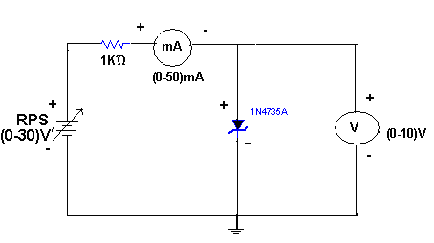
REGULATION CHARACTERISTICS:-
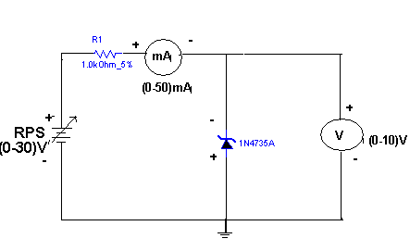

EXPECTED WAVEFORMS:-

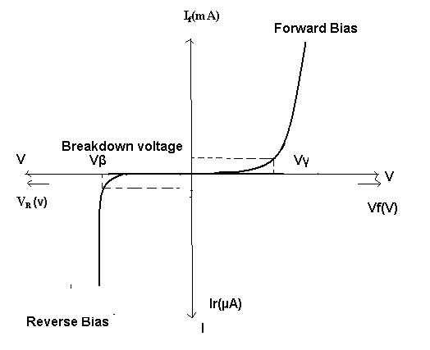

PROCEDURE: -
Forward bias characteristics
1. Connect the circuit diagram as shown in figure for Forward bias using zener diode
2. Switch on the RPS supply voltage Vs and vary in steps from 0V onwards (0.1V,
0.2V……1V) note down the forward current (If) through the diode for different forward
Voltages (Vf) across the diode without exceeding the rated value (Vs=10V)
3. Tabulate the results in the tabular form.
4. Plot the graph between Vf & If.

Reverse bias characteristics
1. Connect the circuit diagram as shown in figure for Reverse bias using Zener diode.
2. Now vary RPS supply voltage Vs in steps from 0V onwards (1V, 2V……10V) note
down the Reverse current (Ir) through the diode for different Reverse voltages (Vr)
across the diode without exceeding the rated value (Vr Max=15V)
3. Tabulate the results in the tabular form.
4. Plot the graph between Vr & Ir.

TABULAR COLUMN: Forward Bias

SL. No | Forward voltage (Vf) | Forward current (If)
1 | 0
2 | 0.15
3 | 0.25
4 | 0.3
5 | 0.4
6 | 0.5
7 | 0.6
8 | 0.7
9 | 0.72
10 | 0.75

TABULAR COLUMN: Reverse Bias

SL. No | Forward voltage (Vf) | Forward current (If)
1 | 1
2 | 2
3 | 3
4 | 4
5 | 5
6 | 6
7 | 7
8 | 8
9 | 9
10 | 10

PRECAUTIONS:
- Check the wires for continuity before use.
- Keep the power supply at Zero volts before Start.
- All the contacts must be intact.

RESULT: -

The Characteristics of the Forward and Reverse biased Zener Diode and the Zener Break Down Voltage from the Characteristics are Observed.
Zener Breakdown Voltage = Volts.
Forward Bias Resistance = Ohms
Reverse Bias Resistance = Ohms

VIVA QUESTIONS:-
- What is Zener diode?
- Can Zener be used as a rectifier?
- What are the voltage ratings of zener diode?
- Give advantages of zener diode?
- How zener diode behaves in foreard bias?
- What type of temp? Coefficient does the zener diode have?
- If the impurity concentration is increased, how the depletion width effected?
- Does the dynamic impendence of a zener diode vary?
- Explain briefly about avalanche and zener breakdowns?
- Draw the zener equivalent circuit?
- Differentiate between line regulation & load regulation?
- In which region zener diode can be used as a regulator?
- How the breakdown voltage of a particular diode can be controlled?
- What type of temperature coefficient does the Avalanche breakdown has?
- By what type of charge carriers the current flows in zener and avalanche breakdown diodes?
- What is static characterstics of diode?
- Can Zener be used as a integrator?
- What are the rating voltages of zener diode?
- Give disadvantages of zener diode?
- How zener diode behaves in forward bias?
- What type of temp Coefficient does the zener diode have?
- If the impurity concentration is decreased, how the depletion width effected?
- Does the dynamic impendence of a diode vary?
- Explain briefly about avalanche breakdown?
- Draw the zener equal circuit?
- Differentiate between line & load regulation?
- In which region zener diode can be used as a integratorr?
- How the cut in voltage of a particular diode can be controlled?
- What type of temperature coefficient does the zener breakdown has?
- what type of charge carriers the voltage flows in zener and avalanche breakdown diodes?
- Find the difference between P-N junction Diode and Zener diode in forward bias condition?
- Find the difference between P-N junction Diode and Zener diode in Reverse bias condition?
- Find the Break down voltage for given Zener Diode?
- Define what happens to a series current,load current and zener current when the dc input voltage of zener regulator increases.
- How does the Zener breakdown voltage varies with temperature.
- How does the avalanche breakdown voltage varies with temperature.
- A 9.1-V zener diode exhibits its nominal voltage at a test current of 28 mA. At this current the incremental resistance is specified as 5 Ω. Find VZ0 of the Zener model.
- Zener diodes can be effectively used in voltage regulator. However, they are these days being replaced by more efficient
- The other name for Zener diode is.
- Why zener diode is used as voltage regulator.
- Explain what is meant by the temperature coefficient?
- Why zener diode is always reverse biased
- How the width of depletion region in the reverse biased diode varies with the impurity concentration
- Under what condition zener diode behaves like pn junction diode.
- How the value of potential barrier depends on the amount of doping of the semiconductor.
- Difference between intrinsic and extrinsic semiconductor
- Why is a zener diode generally not connected to forward diode.
- What is the temperature effect on reverse saturation current and barrier voltage.
- How the name of the zener came.
- Is the breakdown region in zener is really destructible.

Design Problems
- Reverse bias characteristics of Zener Si diode with 5.6V.
- Reverse bias characteristics of Zener Si diode with 6.2V.
- Reverse bias characteristics of Zener Si diode with 5.6V with R = 2K.
- Reverse bias characteristics of Zener Si diode with 5.6V with R = 2.5K.
- Verify the operation of Zener acts as voltage regulator.
- Verify the operation of Zener acts as voltage regulator with R = 2K and R_{L} = 5K
- Reverse bias characteristics of Zener Si diode with 5.6V with V_{RPS} = 0 – 15V
- Reverse bias characteristics of Zener Si diode with 5.6V with V_{RPS} = 0 – 20V
- Reverse bias characteristics of Zener Si diode with 6.2V with V_{D} = 10 V and I_{D} = 10 mA
- Reverse bias characteristics of Zener Si diode with 6.2V with V_{D} = 20 V and I_{D} = 15 mA
- Plot the Reverse Bias characteristics for the Zener diode when I/P resistance is 10k?
- Find the effect of change in characteristics of Zener diode connected in Reverse Bias condition when input resistance is changed from 10k to 20K?
- Find the effect of change in characteristics of Zener diode connected in Reverse Bias condition when input resistance is changed from 20k to 10K?
- Reverse bias characteristics of Zener Si diode with 6.2V with V_{D} = 12 V ?
- Find output voltage of Zener Si diode with 6.2V with V_{D} = 10V?
- Find output voltage of Zener Si diode with 6.2V with V_{D} =5V?
- Find output voltage of Zener Si diode with 6.2V with V_{D} =6.2V?
- Reverse bias characteristics of Zener Si diode with 6.5V?
- Reverse bias characteristics of Zener Si diode with 2.6V?
- Reverse bias characteristics of Zener Si diode with 2.6V with R = 1K?
- Reverse bias characteristics of Zener Si diode with 2.6V with R = 2.0K?
- Verify the operation of Zener acts as voltage integrator?
- Verify the operation of Zener acts as voltage regulator with R = 1K and R_{L} = 2K?
- Reverse bias characteristics of Zener Si diode with 2.6V with V_{RPS} = 0 – 10V?
- Reverse bias characteristics of Zener Si diode with 2.6V with V_{RPS} = 0 – 10V?
- Reverse bias characteristics of Zener Si diode with 2.2V with V_{D} = 20 V and I_{D} = 5 mA?
- Reverse bias characteristics of Zener Si diode with 6.2V with V_{D} = 10 V and I_{D} = 10 mA?

REALTIME APPLICATIONS:
With growing popularity of smart phones, android based projects are being preferred these days. These projects involve use of Bluetooth technology based device. These Bluetooth devices require about 3V voltage for operation. In such cases, a zener diode is used to provide a 3V reference to the Bluetooth device.
Another application involves use of Zener diode as a voltage regulator. Here the AC voltage is rectified by the diode D1 and filtered by the capacitor. This filtered DC voltage is regulated by the diode to provide a constant reference voltage of 15V. This regulated DC voltage is used to drive the control circuit, used to control the switching of light, as in an automated lighting control system.

EXPT NO: 3.

HALF WAVE RECTIFIR WITH & WITHOUT FILTER.

AIM: -

1. To find ripple factor & regulation for Half wave rectifier.
2. To examine the input and output wave forms..

EQUIPMENTS & COMPONENTS REQUIRED:

S.No | Device | Range/Rating | Qty
1. | Transformer | 6-0-6V or 9-0-9V | 1
2. | Diode | In4007, | 1
3. | Resistors or DRB | 1kΩ,4.7k,10kΩ,22K,100k | 1each
4. | Connecting wires & bread board

THEORY: -
During positive half-cycle of the input voltage, the diode D1 is in forward bias and conducts through the load resistor R1. Hence the current produces an output voltage across the load resistor R1, which has the same shape as the +ve half cycle of the input voltage. During the negative half-cycle of the input voltage the diode is reverse biased and there is no current through the circuit. i.e, the voltage across R1 is zero. The net result is that only the +ve half cycle of the input voltage appears across the load. The average value of the half wave rectified o/p voltage is the value measured on dc voltmeter. For practical circuits, transformer coupling is usually provided for two reasons.
1. The voltage can be stepped-up or stepped-down, as needed.
2. The ac source is electrically isolated from the rectifier. Thus preventing shock hazards in the
secondary circuit.

CIRCUIT DIAGRAM:

WITHOUT FILTER :
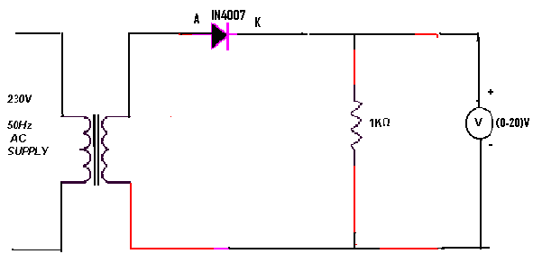

WITH FILTER:

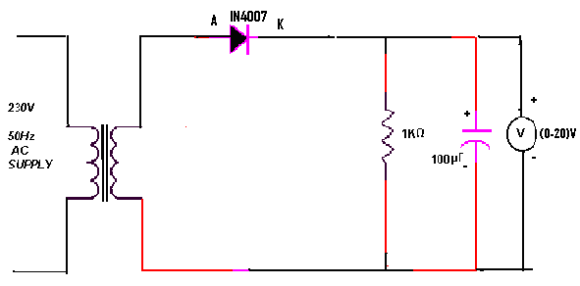

PROCEDURE: -
Without filter:
- Connect the circuit as shown in the circuit diagram.
- Note down the voltage across the secondary of transformer and across the output terminals (VO) i.e. across load resistor RL (with 1K, 4.7K, 10K, 100k) use DRB Decade resistance box or discrete component.
- Vary the RL load resistor for different values note down AC and DC voltages across the RL using DMM or CRO.
- Now Disconnect the RL and note the No Load voltage VNL.
- Calculate the ripple factor & regulation using formula for different loads and tabulate.

With filter:
- Connect a capacitor (100µf/35V) across the load resistance RL..
- Note down the voltage across the secondary of transformer and across the output terminals (Vo) i.e. across load resistor RL (with 1K, 4.7K, 10K, 100k) use DRB Decade resistance box or discrete component.
- Vary the RL load resistor for different values note down AC and DC voltages across the RL using DMM or CRO.
- Now Disconnect the RL and note the No Load voltage VNL.
Calculate the ripple factor & regulation using formula for different loads and

OBSERVATIONS:
 |  |  |  | VNL= --------- volts
SL No | RL (Ohm) | VFL=Vdc | Vac | Ripple factorг=Vac/Vdc | % Regulation
Were % of regulation =VNL-VFL/VFL*100
[VNL= No load voltage
VFL= Full load voltage]

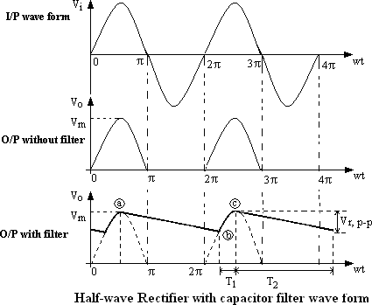
WAVEFORMS:

Theoretical calculations for Ripple factor:-

Without Filter:-
Vrms=Vm/2
Vm=2Vrms
Vdc=Vm/П
Ripple factor r=√ (Vrms/ Vdc )² -1 =1.21

With Filter:-
Ripple factor, r=1/ (2√3 f C R)
Where f =50Hz
C =100µF
R_{L}=1KΩ

PRECAUTIONS:
1. The primary and secondary sides of the transformer should be carefully identified.
2. The polarities of the diode & capacitor should be carefully connected.
3. While determining the % regulation, first Full load should be applied and then it should be decremented in steps.
4. Avoid loose contact.
5. CRO must be handled carefully. Use CH1 for input and CH2 for output signal.

RESULT:
Observe Input and Output Wave forms and Calculate ripple factor and percentage of regulation in Half wave rectifier with and without filter.

Without Filter:
Ripple Factor : Regulation :

With Capacitor Filter:
Ripple Factor : Regulation :

VIVA QUESTIONS:

1. What is the PIV of Half wave rectifier?
2. What is the efficiency of half wave rectifier?
3. What is the rectifier?
4. What is the difference between the half wave rectifier and full wave rectifier?
5. What is the o/p frequency of Bridge Rectifier?
6. What are the ripples?
7. What is the function of the filters?
8. What is TUF?
9. What is the average value of o/p voltage for HWR?
10. What is the peak factor?
11.What is the PIV of Half wave rectifier?
12. What is the efficiency of half wave rectifier?
13. What is the rectifier?
14. What is the difference between the half wave rectifier and full wave rectifier?
15. What is the o/p frequency of Bridge Rectifier?
16. What are the ripples?
17. What is the function of the filters?
18. What is TUF?
19. What is the average value of o/p voltage for HWR?
20. What is the peak factor?
21. What is the PIV of Half wave rectifier?
22. What is the efficiency of half wave rectifier?
23. What is the rectifier?
24. What is the difference between the half wave rectifier and full wave rectifier?
25. What is the o/p frequency of Bridge Rectifier?
26. What are the ripples?
27. What is the function of the filters?
28. What is TUF?
29. What is the average value of o/p voltage for HWR?
30. What is the peak factor?
31. Give the importance of peak inverse voltage
32.define why half wave rectifier is not in dc power supply
33.why diodes are not operated in the breakdown region in rectifiers.
34.the output of the 60Hz full wave bridge rectifier had a 60Hz ripple.Is this circuit working properly.
35.define why series Inductor and L-section filters cannot be used with half-wave rectifier
36.why capacitor input filter is preferred to choke input filter.
37.define ripple as referred to in a rectifier circuit.
38. What is load regulation and line regulation in power supplies?
39. What are the different types of filters used for the rectifiers?
40. Which is preferable- High regulation or low regulation?
41. What is the principle of transformer operation?
42. Why step down transformer is used in HWR?
43. What is the output of HWR? Is it unidirectional or constant?
44. Define line and load regulation.
45. What is the % of load regulation ?
46. What Is The Importance Of Peak Inverse Voltage?
47. Why π-filters Are Not Suitable For Varying Loads?
48. Define Why R-c Filters Are Suitable Only For Light Loads?
49.what is the difference between AC and DC supply.what are the advantages of each.
50.give the requirements of linear mode power supply.

Design Problems
1. Examine the I/O waveforms of HWR without filter R_{L} = 2K
2. Examine the I/O waveforms of HWR without filter R_{L} = 4.5K
3. Examine the I/O waveforms of HWR without filter R_{L} = 2K using Ge diode.
4. Examine the I/O waveforms of HWR without filter R_{L} = 4.5K using Ge diode.
5. Examine the I/O waveforms of HWR without filter R_{L} = 2K, change the diode location.
6. Examine the I/O waveforms of HWR without filter R_{L} = 4.5K invert diode.
7. Examine the I/O waveforms of HWR with filter R_{L} = 5K, C = 0.1 µF
8. Examine the I/O waveforms of HWR with filter R_{L} = 2K, C = 0.047 µF
- Examine the I/O waveforms of HWR with filter R_{L} = 2K, C = 0.047 µF using Ge diode.
- Examine the I/O waveforms of HWR with filter R_{L} = 5K, C = 0.1 µF, invert diode.
Plot the I/O waveforms of HWR without filter R_{L} = 2K?
32. Plot the I/O waveforms of HWR without filter R_{L} = 4.5K?
33. Plot the I/O waveforms of HWR without filter R_{L} = 2K using Ge diode?
- Plot the I/O waveforms of HWR without filter R_{L} = 4.5K using Ge diode?
- Plot the I/O waveforms of HWR without filter R_{L} = 2K, change the diode location?
- Plot the I/O waveforms of HWR without filter R_{L} = 4.5K invert diode?
- Plot the I/O waveforms of HWR with filter R_{L} = 5K, C = 0.1 µF?
- Plot the I/O waveforms of HWR with filter R_{L} = 2K, C = 0.047 µF?
- Plot the I/O waveforms of HWR with filter R_{L} = 2K, C = 0.047 µF using Ge diode?
- Plot the I/O waveforms of HWR with filter R_{L} = 5K, C = 0.1 µF, invert diode?
- Plot the I/O waveforms of HWR without filter R_{L} = 2K?
- Plot the I/O waveforms of HWR without filter R_{L} = 4.5K?
- Plot the I/O waveforms of HWR without filter R_{L} = 2K using Ge diode?
- Plot the I/O waveforms of HWR without filter R_{L} = 4.5K using Ge diode?
- Plot the I/O waveforms of HWR without filter R_{L} = 2K, change the diode location?
- Plot the I/O waveforms of HWR without filter R_{L} = 4.5K invert diode?
- Plot the I/O waveforms of HWR with filter R_{L} = 5K, C = 0.1 µF?
- Plot the I/O waveforms of HWR with filter R_{L} = 2K, C = 0.047 µF?
- Plot the I/O waveforms of HWR with filter R_{L} = 2K, C = 0.047 µF using Ge diode?
- Examine the I/O waveforms of HWR with filter R_{L} = 5K, C = 0.1 µF, invert diode?

REALTIME APPLICATIONS:
The primary application of rectifiers is to derive DC power from an AC supply (AC to DC converter). Virtually all electronic devices require DC, so rectifiers are used inside the power supplies of virtually all electronic equipment.
Converting DC power from one voltage to another is much more complicated. One method of DC-to-DC conversion first converts power to AC (using a device called an inverter), then uses a transformer to change the voltage, and finally rectifies power back to DC. A frequency of typically several tens of kilohertz is used, as this requires much smaller inductance than at lower frequencies and obviates the use of heavy, bulky, and expensive iron-cored units.
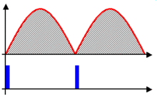
Output voltage of a full-wave rectifier with controlled thyristors
Rectifiers are also used for detection of amplitude modulated radio signals. The signal may be amplified before detection. If not, a very low voltage drop diode or a diode biased with a fixed voltage must be used. When using a rectifier for demodulation the capacitor and load resistance must be carefully matched: too low a capacitance makes the high frequency carrier pass to the output, and too high makes the capacitor just charge and stay charged.
Rectifiers supply polarised voltage for welding. In such circuits control of the output current is required; this is sometimes achieved by replacing some of the diodes in a bridge rectifier with thyristors, effectively diodes whose voltage output can be regulated by switching on and off with phase fired controllers.

EXPT NO: 4.

FULL WAVE RECTIFIR WITH & WITHOUT FILTER.

AIM: -

1. To find ripple factor & regulation for full wave rectifier.
2. To examine the input and output wave forms..

EQUIPMENTS & COMPONENTS REQUIRED:

S.No | Device | Range/Rating | Qty
1. | Transformer | 6-0-6V or 9-0-9V | 1
2. | Diode | In4007 | 2 or 4
3. | Resistors | 1kΩ,2.2k,3.3kΩ,4.7K,10k | 1each
4. | Connecting wires & bread board

THEORY:-
The circuit of a center-tapped full wave rectifier uses two diodes D1&D2. During positive half cycle of secondary voltage (input voltage), the diode D1 is forward biased and D2is reverse biased. The diode D1 conducts and current flows through load resistor RL.
During negative half cycle, diode D2 becomes forward biased and D1 reverse biased. Now, D2 conducts and current flows through the load resistor RL in the same direction. There is a continuous current flow through the load resistor RL, during both the half cycles and will get unidirectional current as show in the model graph. The difference between full wave and half wave rectification is that a full wave rectifier allows unidirectional (one way) current to the load during the entire 360 degrees of the input signal and half-wave rectifier allows this only during one half cycle (180 degree)

CIRCUIT DIAGRAM:

WITHOUT FILTER:

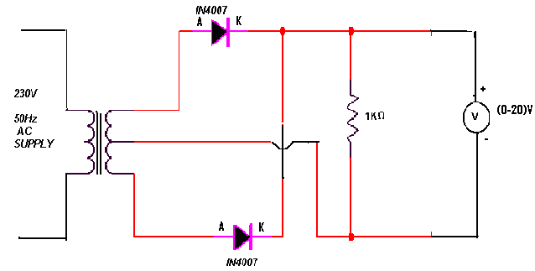

WITH FILTER:
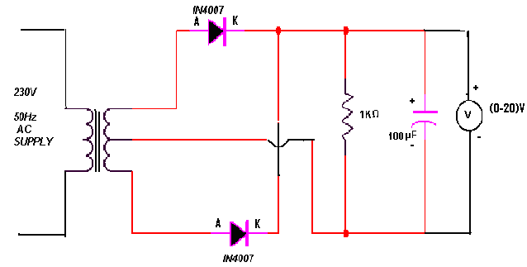

PROCEDURE: -
Without filter:
1. Connect the circuit as shown in the circuit diagram.
2. Note down the voltage across the secondary of transformer and across the output
terminals (Vo) i.e. across load resistor RL (with 1K, 4.7K, 10K, 100k) use DRB Decade resistance box or discrete component.
3.Vary the RL load resistor for different values note down AC and DC voltages across the RL using DMM or CRO.
4. Now Disconnect the RL and note the No Load voltage VNL.
5. Calculate the ripple factor & regulation using formula for different loads and tabulate.

With filter:
- Connect a capacitor (100µf/35V) across the load resistance RL..
- Note down the voltage across the secondary of transformer and across the output terminals (Vo) i.e. across load resistor RL (with 1K, 4.7K, 10K, 100k) use DRB Decade resistance box or discrete component.
- Vary the RL load resistor for different values note down AC and DC voltages across the RL using DMM or CRO.
- Now Disconnect the RL and note the No Load voltage VNL.
- Calculate the ripple factor & regulation using formula for different loads and tabulate.

OBSERVATIONS:
 |  |  |  | VNL= --------- volts
SL No | RL (Ohm) | VFL=Vdc | Vac | Ripple factorг=Vac/Vdc |  | % Regulation
 |  |  |  | With filter | Without filter | With filter | Without filter
Were % of regulation =VNL-VFL/VFL*100
[VNL= No load voltage
VFL= Full load voltage]

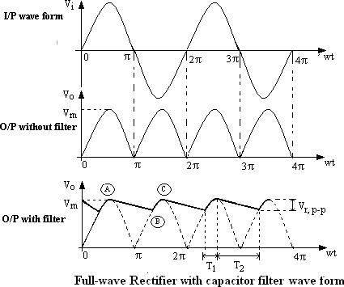
waveforms :

THEORITICAL CALCULATIONS:-
Vrms = Vm/ √2
Vm =Vrms√2
Vdc=2Vm/П
(i)Without filter:
Ripple factor, r = √ ( Vrms/ Vdc )² -1 = 0.482
(ii)With filter:
Ripple factor, r = 1/ (4√3 f C R_{L}) where f =50Hz
C =100µF
R_{L}=1KΩ

PRECAUTIONS:

- Check the wires for continuity before use.
- Keep the power supply at Zero volts before Start.
- All the contacts must be intact.

RESULT: Observe Input and Output Wave forms and Calculate ripple factor and percentage of regulation in Full-wave rectifier with and without filter.

Without Filter:
Ripple Factor : Regulation :

With Capacitor Filter:
Ripple Factor : Regulation :

VIVA QUESTIONS:-
1. Define regulation of the full wave rectifier?
2. Define peak inverse voltage (PIV)? And write its value for Full-wave
rectifier?
3. If one of the diode is changed in its polarities what wave form would you?
get?
4. Does the process of rectification alter the frequency of the waveform?
5. What is ripple factor of the Full-wave rectifier?
6. What is the necessity of the transformer in the rectifier circuit?
7. What are the applications of a rectifier?
8. What is meant by ripple and define Ripple factor?
9. Explain how capacitor helps to improve the ripple factor?
10. Define regulation of the full wave rectifier?
11. Define peak inverse voltage (PIV)? And write its value for Full-wave
rectifier?
12. If one of the diode is changed in its polarities what wave form would you?
get?
13. Does the process of rectification alter the frequency of the waveform?
14. What is ripple factor of the Full-wave rectifier?
15. What is the necessity of the transformer in the rectifier circuit?
16. What are the applications of a rectifier?
17. What is meant by ripple and define Ripple factor?
18. Explain how capacitor helps to improve the ripple factor?
19. Define regulation of the full wave rectifier?
20. Define peak inverse voltage (PIV)? And write its value for Full-wave
rectifier?
21. If one of the diode is changed in its polarities what wave form would you?
get?
22. Does the process of rectification alter the frequency of the waveform?
23. What is ripple factor of the Full-wave rectifier?
24. What is the necessity of the transformer in the rectifier circuit?
25. What are the applications of a rectifier?
26. What is meant by ripple and define Ripple factor?
27. Explain how capacitor helps to improve the ripple factor?
28. What is ripple factor of the Full-wave rectifier?
29. What is the necessity of the transformer in the rectifier circuit?
30. What are the applications of a rectifier?
31. Compare the efficiency of HWR you have done with the FWR circuit designed with capacitor filter?
- Compare the efficiency of HWR you have done with the FWR circuit designed with inductor filter?
- Compare the efficiency of FWR circuit designed with inductor filter and Capacitor filter?
- Compare the performance between HWR with Filter and FWR without filter?
- Compare between HWR and FWR without filters?
- Give some rectifications technologies?
- In filters capacitor is always connected in parallel, why?
- What is the value of PIV of a center tapped FWR?
- What is the location of poles of filter in S-plane?
- What is the output of FWR with filter? Is it unidirectional?
- Define Ripple factor ‘γ’ and its values for the three types of rectifiers.
- What is the value of No load voltage for all the three types of the rectifiers
- What are the different types of filters used for the rectifiers?
- DC average current of a center taped full wave rectifier
(Where I_{m} is the maxI_{m}um peak current of input)
- DC power output of center taped full wave rectifier is equal to
(I_{m} is the peak current and R_{L} is the load resistance)
- If input frequency is 50Hz then ripple frequency of center taped full wave rectifier will be equal to
- Transformer utilization factor of a center taped full wave rectifier is equal to
- If peak voltage on a center taped full wave rectifier circuit is 5V and diode cut-in voltage is 0.7, then peak inverse voltage on diode will be
- In an center taped full wave rectifier, the input sine wave is 20sin500 ᴨt. The average output voltage is
- In an center taped full wave rectifier, the input sine wave is 200sin50 ᴨt. If load resistance is of 1k then average DC power output of half wave rectifier is

Design Problems
- Study the performance of FWR with filter R_{L} = 2K, C = 0.047 µF
- Study the performance of FWR with filter R_{L} = 15K, C = 0.047 µF using Ge diode.
- Study the performance of FWR with filter R_{L} = 5K, C = 0.1 µF, invert diode.
- Study the performance of FWR with filter R_{L} = 5K, C = 0.94 µF, invert diode.
- Study the performance of FWR with R_{L} = 5K using GE diode, invert diodes.
- Study the performance of FWR with filter R_{L} = 10K, C = 0.1 µF
- Study the performance of FWR with filter R_{L} = 2K, C = 0.047 µF
- Study the performance of FWR with filter R_{L} = 15K, C = 0.047 µF using Ge diode.
- Study the performance of FWR with filter R_{L} = 5K, C = 0.1 µF, invert diode.
- Study the performance of FWR with filter R_{L} = 5K, C = 0.94 µF, invert diode
- Study the performance of FWR with filter R_{L} = 100K, C = 0.1 µF?
- Find the efficiency of the full wave rectifier designed with a CLC Filter?
- Find the ripple factor of the FWR with Capacitor filter?
- Find the ripple factor of the FWR with Inductor filter?
- Study the performance of FWR with filter R_{L} = 50K, C = 0.047 µF?
- Study the performance of FWR with R_{L} = 2K?
- Study the performance of FWR with R_{L} = 5K?
- Study the performance of FWR with R_{L} = 5K using GE diode?
- Study the performance of FWR with R_{L} = 5K, invert the diodes?
- Study the performance of FWR with R_{L} = 2K?
- Study the performance of FWR with R_{L} = 5K?
- Study the performance of FWR with R_{L} = 5K using GE diode?
- Study the performance of FWR with R_{L} = 5K, invert the diodes?
- Study the performance of FWR with R_{L} = 5K using GE diode, invert diodes?
- Study the performance of FWR with filter R_{L} = 10K, C = 0.1 µF

REALTIME APPLICATIONS:
The full wave rectifier circuit is one that is widely used for power supplies and many other areas where a full wave rectification is required.
The full wave rectifier circuit is used in most rectifier applications because of the advantages it offers. While it is a little more complicated, this normally outweighs the disadvantages. However sometimes it may not be optimum or necessary to use a full wave rectifier circuit.

EXPT NO: 5.

INPUT & OUTPUT CHARACTERISTICS OF A BJT IN COMMON EMITTER (CE) CONFIGURATION

AIM: -
1. To study the input and output characteristics of transistor (BJT) connected in common
Emitter configuration.
2. To calculate current gain β.
3. To calculate input resistance Ri & output resistance Ro.

EQUIPMENTS & COMPONENTS REQUIRED:

S.No | Device | Range/Rating | Qty
1. | Regulated DC supply voltage(RPS) | 0-30V | 1
2. | Voltmeter | 0-1V or 0-10v,0-20V | 1
3. | Ammeter | 0-10mA,200mA | 1
4. | Connecting wires & bread board
5 | Transistor BC 107 or 2n2222 or BC547 | NPN | 1
6 | Resistor | 1K,100K | 1

THEORY:

A transistor is a three terminal device. The terminals are emitter, base, collector. In common emitter configuration, input voltage is applied between base and emitter terminals and output is taken across the collector and emitter terminals. Therefore the emitter terminal is common to both input and output. The input characteristics resemble that of a forward biased diode curve. This is expected since the Base-Emitter junction of the transistor is forward biased. As compared to CB arrangement IB increases less rapidly with VBE . Therefore input resistance of CE circuit is higher than that of CB circuit. The output characteristics are drawn between Ic and VCE at constant IB. the collector current varies with VCE unto few volts only. After this the collector
current becomes almost constant, and independent of VCE. The value of VCE up to which the collector current changes with V CE is known as Knee voltage. The transistor always operated in the region above Knee voltage, IC is always constant and is approximately equal to IB.
The current amplification factor of CE configuration is given byΒ = ΔIC/ΔIB.

CIRCUIT DIAGRAM:

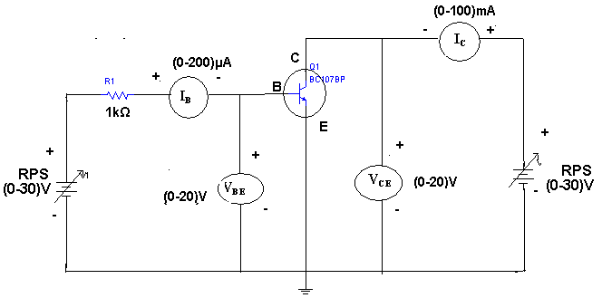

PROCEDURE: -
Input characteristics:
- Connect the circuit according to the circuit diagram of input characteristics
- Keep (Collector to Emitter Voltage) VCE=0V) by varying VCC (collector supply voltage). Increasing VBB (Base supply Voltage from 0 onwards (0.1V, 0.2V….0.75V) observe IB (Base current) for different values of VBE (Base to Emitter voltage).
- Repeat the Step 2 for Different (collector to Emitter voltage) VCE i.e. 3V & 6V.
- Tabulate the results in the tabular form and plot the graph.
Output characteristics:
- Connect the circuit according to the circuit diagram of output characteristic.
- Keep (collector supply voltage) VCC=0V. Increase (Base supply Voltage) VBB to get Base current IB= 3µA.
- Now increase (Collector supply voltage) VCC from 0 onwards and observe the Collector current IC for different Values of (Collector to Emitter voltage ) VCE Without exeding the rated value (IC=15mA)
- Tabulate the results in the tabular coloum and plot the graph.

OBSERVATIONS:

INPUT CHARACTERISTICS:

S.NO | V_{CE} = 1V |  | V_{CE} = 2V |  | V_{CE} = 4V
S.NO | V_{BE}(V) | I_{B}(μA) | V_{BE}(V) | I_{B}(μA) | V_{BE}(V) | I_{B}(μA)

OUT PUT CHAREACTARISTICS:

S.NO | I_{B} = 5μA |  | I_{B} = 10μA |  | I_{B} = 15 μA
S.NO | V_{CE}(V) | I_{C}(mA) | V_{CE}(V) | I_{C}mA) | V_{CE}(V) | I_{C}(mA)

EXPECTED GRAPHS:
INPUT CHARACTERSTICS:
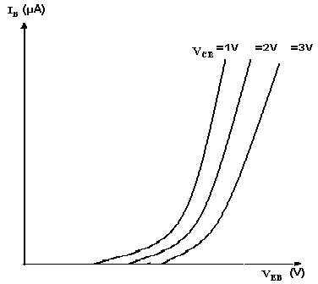

OUTPUT CHARECTERSTICS:
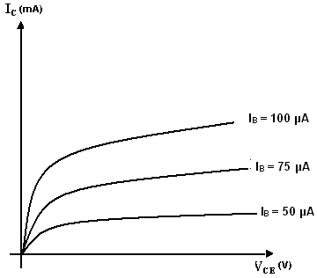
Preacutions:
1. Always keep the supply Voltage Knobs i.e. VCE, VBE positions at minimum position when
switching on & off .
2. Never load the meters above its rated range.
3. Avoid loose connections at the junction.
To find the h –parameters:
Calculation of h_{ie}:
Mark two points on the Input characteristics for constant V_{CE}. Let the coordinates of these two points be (V_{BE1,} I_{B1}) and (V_{BE2,} I_{B2}).
h_{ie} = V_{BE2} – V_{BE1}
---------------
I_{B2} – I_{B1}

Calculation of h_{re}:
Draw a horizontal line at some constant I_{B} value on the Input characteristics. Find VCE2, VCE1, VBE2,VBE1
h_{rb} = VBE2 - VBE1
-----------------------
VCB2 -VCB1

Calculation of h_{fe}:
Draw a vertical line on the out put characteristics at some constant V_{CE} value. Find Ic2, Ic1 and IB2, IB1.

h_{fe} = I_{C2} – I_{C1}
------------
I_{B2} – I_{B1}

Calculation of h_{oe}:
On theOutput characteristics for a constant value of I_{B} mark two points with coordinates (V_{CE2} , I_{C2}) and (V_{CE1}, I_{C1}) .
IC2 - IC1
h_{oe} = --- -------
VCE2 - VCE1

RESULTS:
The input and out put characteristics are drawn on the graphs and the h parameters are calculated .
h_{ie}=---------ohms. h_{re}= -----------

h_{oe}=-------- mhos. h_{fe} =-----------

VIVA QUESTIONS:
1. What is the range of β for the transistor?
2. What are the input and output impedances of CE configuration?
3. Identify various regions in the output characteristics?
4. What is the relation between α and β?
5. Define current gain in CE configuration?
6. Why CE configuration is preferred for amplification?
7. What is the phase relation between input and output?
8. Draw diagram of CE configuration for PNP transistor?
9. What is the power gain of CE configuration?
10. What are the applications of CE configuration? . What is the range of β for the transistor?
2. What are the input and output impedances of CE configuration?
3. Identify various regions in the output characteristics?
4. What is the relation between α and β?
5. Define current gain in CE configuration?
6. Why CE configuration is preferred for amplification?
7. What is the phase relation between input and output?
8. Draw diagram of CE configuration for PNP transistor?
9. What is the power gain of CE configuration?
10. What are the applications of CE configuration?
11. What is the range of β for the transistor?
12. What are the input and output impedances of CE configuration?
13. Identify various regions in the output characteristics?
14. What is the relation between α and β?
15. Define current gain in CE configuration?
16. Why CE configuration is preferred for amplification?
17. What is the phase relation between input and output?
18. Draw diagram of CE configuration for PNP transistor?
19. What is the power gain of CE configuration?
20. What are the applications of CE configuration?
21. What is Early Effect?
22. Why the doping of collector is less compared to emitter?
23. What do you mean by “reverse active”?
24. What is the difference between CE and Emitter follower circuit?
25. What are the input and output impedances of CE configuration?
26. Identify various regions in the output characteristics?
27. What is the relation between α, β and γ?
28. Define current gain in CE configuration?
29. Why CE configuration is preferred for amplification?
30. What is the phase relation between input and output?
31 Define dopping?
32.Why CE configuration is used mostly?
33. A germanium transistor with α=0.98 gives a reverse saturation current I_{CBO}=10µA in a CB configuration. When it is used in CE configuration with a base current of 0.22µA, calculate the collector current.
34. In I_{CEO}, wt does the subscript ‘CEO’ mean?
35. The range of β is _________
36. Define the point on the DC load line which is represented by ‘Q’ is called _________
37. The input resistance is given by ______
38 What are the output impedances of CE configuration
39 Draw the input characteristics of CE configuration
40, Which of the following cases damage the transistor?
41.When the collector junction is reverse biased and emitter junction is forward biased, the operating region of the transistor is called_________
42. The small amount of current which flows even when base current I_{B}=0 is called________
43. Which of the points locates the quiescent point?
44 Which of the parameters corresponds to the output circuit of a CE transistor?
45. What are DC characteristic used to prove that the transistor is indeed biased in saturation mode?
46.List the different configurations used
47.Define biasing
48.What are the different biasing methods?
49.List the applications of common emitter configuration
50.which biasing techniques are used mostly for CE Configuration?

Design Problems
- Input & output characteristics of BC 107 transistor in CE configuration with R_{I} = 50K.
- Input & output characteristics of BC 107 transistor in CE configuration with R_{O} = 2K.
- I/O characteristics of BC 107 transistor in CE configuration with R_{I} = 50K R_{O} = 2K
- Input & output characteristics of BC 107 transistor in CE configuration with R_{I} = 150K.
- I/O characteristics of BC 107 transistor in CE configuration with R_{I} = 150K R_{O} = 2K
- Input & output characteristics of SL 100 transistor in CE configuration with R_{I} = 50K.
- Input & output characteristics of SL 100 transistor in CE configuration with R_{O} = 2K.
- I/O characteristics of PNP transistor in CE configuration with R_{I} = 50K R_{O} = 2K
- Input & output characteristics of PNP transistor in CE configuration with R_{I} = 150K.
- I/O characteristics of PNP transistor in CE configuration with R_{I} = 150K R_{O} = 2K
- Input & output characteristics of BC 107 transistor in CE configuration with R_{I} = 50K.
- Input & output characteristics of BC 107 transistor in CE configuration with R_{O} = 2K.
- I/O characteristics of BC 107 transistor in CE configuration with R_{I} = 50K R_{O} = 2K
- Input & output characteristics of BC 107 transistor in CE configuration with R_{I} = 150K.
- I/O characteristics of BC 107 transistor in CE configuration with R_{I} = 150K R_{O} = 2K
- Input & output characteristics of SL 100 transistor in CE configuration with R_{I} = 50K.
- Input & output characteristics of SL 100 transistor in CE configuration with R_{O} = 2K.
- I/O characteristics of PNP transistor in CE configuration with R_{I} = 50K R_{O} = 2K
- Input & output characteristics of PNP transistor in CE configuration with R_{I} = 150K.
- I/O characteristics of PNP transistor in CE configuration with R_{I} = 150K R_{O} = 2K
- Input & output characteristics of BC 107 transistor in CE configuration with R_{I} = 50K.
- Input & output characteristics of BC 107 transistor in CE configuration with R_{O} = 2K.
- I/O characteristics of BC 107 transistor in CE configuration with R_{I} = 50K R_{O} = 2K
- Input & output characteristics of BC 107 transistor in CE configuration with R_{I} = 150K.
- I/O characteristics of BC 107 transistor in CE configuration with R_{I} = 150K R_{O} = 2K
- Input & output characteristics of SL 100 transistor in CE configuration with R_{I} = 50K.
- Input & output characteristics of SL 100 transistor in CE configuration with R_{O} = 2K.
- I/O characteristics of PNP transistor in CE configuration with R_{I} = 50K R_{O} = 2K
- Input & output characteristics of PNP transistor in CE configuration with R_{I} = 150K.
- I/O characteristics of PNP transistor in CE configuration with R_{I} = 150K R_{O} = 2K

REALTIME APPLICATIONS:
Common-emitter amplifiers are also used in radio frequency circuits, for example to amplify faint signals received by an antenna. In this case it is common to replace the load resistor with a tuned circuit. This may be done to limit the bandwidth to a narrow band centered around the intended operating frequency. More importantly it also allows the circuit to operate at higher frequencies as the tuned circuit can be used to resonate any inter-electrode and stray capacitances, which normally limit the frequency response. Common emitters are also commonly used as low-noise amplifiers.

EXPT NO: 6.

INPUT & OUTPUT CHARACTERISTICS OF A BJT IN COMMON BASE

(CB) CONFIGURATION

AIM: -
- To study the input and output characteristics of transistor (BJT) connected in common
Base configuration.
- To calculate current gain α.
- To calculate input resistance Ri & output resistance Ro.

EQUIPMENTS & COMPONENTS REQUIRED:
S.No | Device | Range/Rating | Qty
1. | Regulated DC supply voltage(RPS) | 0-30V | 1
2. | Voltmeter | 0-1Vor 0-10v ,0-20V | 2
3. | Ammeter | 0-10mA,200mA | 2
4. | Connecting wires & bread board
5 | Transistor BC 107 or 2n2222 or BC547 | NPN | 1
6 | Resistor | 1K,10K | 1

Theory: -
The name transistor is derived from TRANSFER RESISTOR. [A transistor transfers a signal level of resistance to another level of resistance]
A transistor is a three terminal active device. The terminals are emitter, base, collector. In CB configuration, the base is common to both inputs (emitter) and output (collector). For normal operation, the E-B junction is forward biased and C-B junction is reverse biased.
There are two types of transistors made of either Ge or Si
- NPN transistor.
- PNP transistor.
NPN and PNP transistors are called Complementary transistors
A transistor can be connected in a circuit in the following three ways depending on which terminal is common to input and output.
- common base configuration
- common emitter configuration
- common collector configuration
In common base configuration, input is applied between emitter and base & output is taken from collector and base as shown in fig.

CHARACTERISTICS OF A COMMON BASE CONFIGURATION:-
The complete electrical behavior of a transistor can be described by specifying the interrelation of the various currents and voltages. The most important characteristics are input and output characteristics
INPUT CHARACTERISTIC: It is given by the graph between emitter current I_{E} and emitter-base voltage V_{EB} at constant collector – base voltage V_{CB.}
Input resistance, r_{i} = ΔVEB /ΔI_{E} at a constant V_{CB}
outPUT CHARACTERISTIC: It is the graph between collector current I_{C} and collector base voltage V_{CB} at constant emitter current I_{E}
output resistance, r₀ = ΔV_{CB} /Δ Ic at constant I_{E}
Properties:
- Input resistance is small (10 Ω- 100 Ω)
- Output resistance is high (1 M Ω)
- Current amplification factor α = at constant V_{CB} (current gain) is low
- Highest voltage gain
- Moderate power gain
- CB amplifier can be designed without self bias circuit
Applications:
- To provide voltage gain without any current gain
- For impedance matching in high frequency applications
DISADVANTAGES:
Because of low input resistance loading effects are high.

CIRCUIT DIAGRAM:
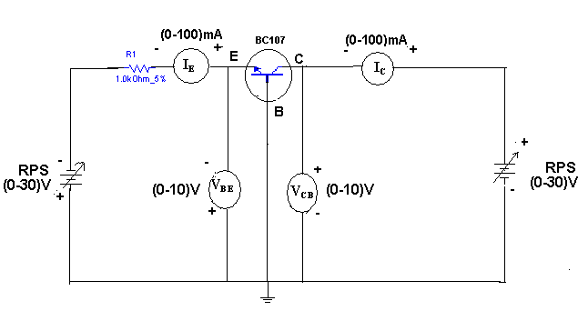

PROCEDURE: -
Input characteristics:
- Connect the circuit according to the circuit diagram of input characteristics
- Keep (Collector to Base Voltage) VCB=0V) by varying VCC (collector supply voltage). Increasing VEE (Emitter supply Voltage from 0 onwards (0.1V, 0.2V….0.75V) observe IE (Emitter current for different values of VEB (Emitter to Base voltage).
- Repeat the Step 2 for Different (collector to Base voltage) VCB i.e. 3V & 6V.
- Tabulate the results in the tabular coloum and plot the graph.
Output characteristics:
- Connect the circuit according to the circuit diagram of output characterists.
- Keep (collector supply voltage) VCC=0V. Increase (Emitter supply Voltage) VEE to get Emitter current IE= 3mA.
- Now increase (Collector supply voltage) VCC from 0 onwards and observe the Collector current IC for different Values of (Collector to Base voltage ) VCB Without exeding the rated value (IC=15mA)
- Tabulate the results in the tabular coloum and plot the graph.

OBSERVATIONS:
INPUT CHARACTERISTICS:

S.No | V_{CB=}0V |  | V_{CB=}1V |  | V_{CB}=2V
S.No | V_{EB}(V) | I_{E(}mA) | V_{EB}(V) | I_{E(}mA) | V_{EB}(V) | I_{E(}mA)

OUTPUT CHARACTERISTICS:

S.No | I_{E=}10mA |  | I_{E=}20mA |  | I_{E}=30mA
S.No | V_{CB}(V) | I_{C(}mA) | V_{CB}(V) | I_{C(}mA) | V_{CB}(V) | I_{C(}mA)

To find the h –parameters: Calculation of h_{ib}:
Mark two points on the Input characteristics for constant V_{CB}. Let the coordinates of these two points be (V_{EB1,} I_{E1}) and (V_{EB2,} I_{E2}).

VEB2 -VEB1 h_{ib} = ----------------
IE2 - IE1

Calculation of h_{rb}:
Draw a horizontal line at some constant I_{E} value on the input characteristics. Find VCB2, VCB1, VEB2, VEB1
VEB2 -VEB1 h_{rb} = -----------------
VCB2 - VCB1

Calculation of h_{fb}:
Draw a vertical line on the Output characteristics at some constant V_{CB} value. Find Ic2, Ic1 and IE2, IE1 .
IC2 - IC1 h_{fb} = ------------
IE2 - IE1

Calculation of h_{ob}:
On the Output characteristics for a constant value of I_{E} mark two points with coordinates (V_{CB2} , I_{C2}) and (V_{CB1} , I_{C1}) .

IC2 - IC1
h_{ob} = --------------- ;
VCB2 - VCB1

EXPECTED GRAPHS:
INPUT CHARACTERISTICS

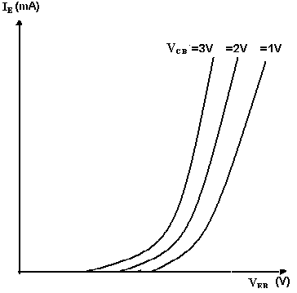

OUTPUT CHARACTERISTICS

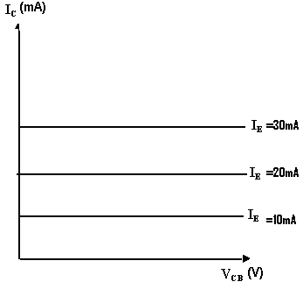
Precautions:
1. Always keep the supply Voltage Knobs i.e. VEB, VCB positions at minimum position when
switching on & off .
2. Never load the meters above its rated range.
3. Avoid loose connections at the junction.

RESULT: -

VIVA QUESTIONS:
- What is bipolar junction transistor?
- Define current amplification factor?
- What are the different configurations of BJT?
- Give the major applications of transistor?
- What are the uses of CB configuration?
- What is the range of α for the transistor?
- Draw the input and output characteristics of the transistor in CB
Configuration?
- What is the relation between α and β?
- What are the input and output impedances of CB configuration?
- Identify various regions in output characteristics?
- Define α (alpha)?
- Draw diagram of CB configuration for PNP transistor?
- What is EARLY effect?
- What is the power gain of CB configuration?
- What is stability factor and thermal runaway?
- What is bipolar junction transistor?
- Define current amplification factor?
- What are the different configurations of BJT?
- Give the major applications of transistor?
- What are the uses of CB configuration?
- What is the range of α for the transistor?
- Draw the input and output characteristics of the transistor in CB
Configuration?
- What is the relation between α and β?
- What are the input and output impedances of CB configuration?
- Identify various regions in output characteristics?
- Define α (alpha)?
- Draw diagram of CB configuration for PNP transistor?
- What is EARLY effect?
- What is the power gain of CB configuration?
- What is stability factor and thermal runaway?
- Find input Resistance of CB configuration for given transitor?
- Find output conductance of CB configuration for given transitor?
- Find current gain of CB configuration for given transitor?
- Find Voltage gain of CB configuration for given transitor?
- Find Reverse Voltage gain of CB configuration for given transitor?
- Find output Resistance of CB configuration for given transitor?
- Find input Resistance of CB configuration for given transitor
- Find output conductance of CB configuration for given transistor?
- Find current gain of CB configuration for given transistor?
- Find Voltage gain of CB configuration for given transistor?
- What do you understand by input and output characteristics of CB configuration.
- Why does the emitter current increases with increase in the reverse bias at collector junction.
- Explain the performance of transistor as switch.
- Define load line.
- Define operating point
- Why BJT is known as current controlled device
- Define thermal runaway.
- What is the need of biasing.
- Define early effect.
- What is the power gain of CB configuration.

Design Problems
- Input & output characteristics of transistor in CB configuration with R_{I} = 5K.
- Input & output characteristics of transistor in CB configuration with R_{O} = 2K.
- Input & output characteristics of transistor in CB configuration with R_{I} = 5K, R_{O} = 2K.
- Input & output characteristics of Ge transistor in CB configuration with R_{I} = 5K.
- Input & output characteristics of Ge transistor in CB configuration with R_{O} = 2K.
- Input & output characteristics of PNP transistor in CB configuration with R_{I} = 5K.
- Input & output characteristics of PNP transistor in CB configuration with R_{O} = 2K.
- I/p & O/p characteristics of PNP transistor in CB configuration with R_{I} = 5K, R_{O} = 2K.
- Input & output characteristics of PNP Ge transistor in CB configuration with R_{I} = 5K.
- Input & output characteristics of PNP Ge transistor in CB configuration with R_{O} = 2K
- Find Input & output characteristics of transistor in CB configuration with R_{I} = 5K?
- Find Input & output characteristics of transistor in CB configuration with R_{O} = 2K?
- Find Input & output characteristics of transistor in CB configuration with R_{I} = 5K, R_{O} = 2K?
- Find Input & output characteristics of Ge transistor in CB configuration with R_{I} = 5K?
- Find Input & output characteristics of Ge transistor in CB configuration with R_{O} = 2K?
- Find Input & output characteristics of PNP transistor in CB configuration with R_{I} = 5K?
- Find Input & output characteristics of PNP transistor in CB configuration with R_{O} = 2K?
- Find I/p & O/p characteristics of PNP transistor in CB configuration with R_{I} = 5K, R_{O} = 2K?
- Find Input & output characteristics of PNP Ge transistor in CB configuration with R_{I} = 5K?
- Find Input & output characteristics of PNP Ge transistor in CB configuration with R_{O} = 2K?

REALTIME APPLICATIONS:
This arrangement is not very common in low-frequency discrete circuits, where it is usually employed for amplifiers that require an unusually low input impedance, for example to act as a preamplifier for moving-coil microphones. However, it is popular in integrated circuits and in high-frequency amplifiers, for example for VHF and UHF, because its input capacitance does not suffer from the Miller effect, which degrades the bandwidth of the common emitter configuration, and because of the relatively high isolation between the input and output. This high isolation means that there is little feedback from the output back to the input, leading to high stability.
This configuration is also useful as a current buffer since it has a current gain of approximately unity (see formulas below). Often a common base is used in this manner, preceded by a common emitter stage. The combination of these two form the cascode configuration, which possesses several of the benefits of each configuration, such as high input impedance and isolation.

EXPT NO: 7.

FET CHARACTERISTICS IN CS CONFIGURATION

AIM: -
- To study the Drain and Transfer characteristics of FET
- To find the Drain resistance Trans-conductance and amplification factor

EQUIPMENTS & COMPONENTS REQUIRED:

S.No | Device | Range/Rating | Qty
1. | (a) Regulated DC supply voltage | 0-30V | 1
2. | Voltmeter | ,0-20V | 2
3. | Ammeter | 0-10mA or 200mA | 1
4. | Connecting wires & bread board
5. | FET transistor | BFW10/11 or BF245A | 1
6. | Resistor | 100Ω,560Ω | 1each

Theory:
The field-effect transistor (FET) is a transistor that uses an electric field to control the shape and hence the conductivity of a channel of one type of charge carrier in a semiconductor material. FETs are unipolar transistors as they involve single-carrier-type operation
A FET is a three terminal device, having the characteristics of high input impedance and less noise, the Gate to Source junction of the FET s always reverse biased. In response to small applied voltage from drain to source, the ntype bar acts as sample resistor, and the drain current increases linearly with VDS. With increase in ID the ohmic voltage drop between the source and the channel region reverse biases the junction and the conducting position of the channel begins to remain constant. The VDS at this instant is called “pinch of voltage”.
If the gate to source voltage (VGS) is applied in the direction to provide additional reverse bias, the pinch off voltage ill is decreased. In amplifier application, the FET is always used in the region beyond the pinch-off.

CIRCUIT DIAGRAM:

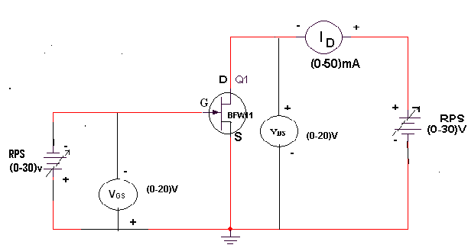

PROCEDURE: -
Drain or Static characteristics
1. Connect the circuit according to the circuit diagram as shown in figure.
2. Keep the power supply knob to minimum position.
3. Switch on supply keep the gate to source voltage VGS=0V.
4. Increase the drain supply VDD from 0V onwards in steps.
5. Note down current Id and Drain to source voltage VDS without exceeding the rated
Value.
6. Repeat the above procedure for VGS=-1V,-0.5V
7. Tabulate the results and plot the graph.
Transfer characteristics:
1. keeping the same circuit connections bring the Knobs of supply t minimum.
2. Now vary VDS drain to source voltage at 1V by Varying VDD Drain supply voltage.
3. Increasing the gate to source voltage VGS from 0V onwards in suitable steps..
4. Note down the corresponding variation in ID until it becomes 0V .
5. Repeat the above 3 step for VDS=2V & 4V constant
6. Tabulate the results and plot graph.

Tabular coloumn
Drain or Static characteristics
VGS=0 |  | VGS=0.5 |  | VGS=0.1
VDS in volts | ID in mA | VDS in volts | ID in mA | VDS in volts | ID in mA

Transfer characteristics
VDS=-1 |  | VDS=-2 |  | VDS=-3
VGS in volts | ID in mA | VGS in volts | ID in mA | VGS in volts | ID in mA

EXPEXTD GRAPH:
TRANSFER CHARACTERISTICS
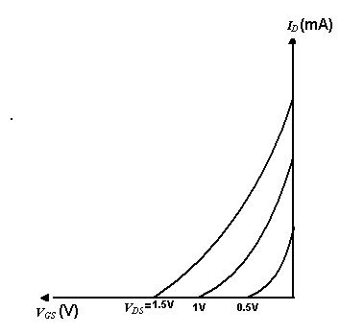
DRAIN CHARACTERISTICS
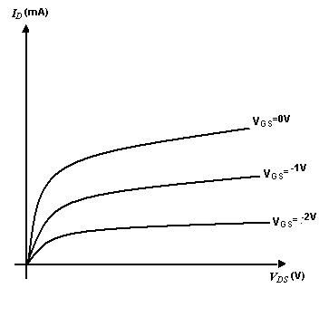

CALCULATIONS: CALCULATION OF r_{d} :
Construct a Triangle on one of the output characteristic for a particular V_{GS} in the active region and find ΔV_{DS} and ΔI_{D}
Now r_{d}= ΔV_{DS}/ ΔI_{D} (V_{GS} = constant)

CALCULATION OF g_{m} :

Construct a Triangle on one of the Transfer characteristics for a particular V_{DS} find ΔV_{GS} and ΔI_{D.}
Now g_{m}= ΔI_{D}/Δ V_{GS} (V_{DS} = constant).

CALCULATION OF μ :
μ = g_{m} x r_{d}.

PRECAUTIONS:
- Alwaya keep the supply voltage knobs i.e VDD, VGG position at minimum position when switching on and off
- Practically FET contains four terminals, which are called source, drain, Gate, substrate.
- Source and case should be short circuited.
- Voltages exceeding the ratings of the FET should not be applied.
- Never load the meters above the rated range.
- Avoid loose contacts at the junction.

RESULT: -

VIVA QUESTIONS:
- Why FET is called as a unipolar device/
- Name the terminals of FET?
- What is the difference between BJT and FET?
- What arte the major applications of FET?
- What are the advantages of FET?
- Difference between MOSFET and FET?
- Give the applications MOSFET?
- What is the basis confurgation of JFET?
- What is deplition mode and enhance mode?
- What is trans-conductance and amplification factor?
- Why FET is called as a unipolar device/
- Name the terminals of FET?
- What is the difference between BJT and FET?
- What arte the major applications of FET?
- What are the advantages of FET?
- Difference between MOSFET and FET?
- Give the applications MOSFET?
- What is the basis confurgation of JFET?
- What is deplition mode and enhance mode?
- What is trans-conductance and amplification factor?
- Why FET is called as a unipolar device/
- Name the terminals of FET?
- What is the difference between BJT and FET?
- What arte the major applications of FET?
- What are the advantages of FET?
- Difference between MOSFET and FET?
- Give the applications MOSFET?
- What is the basis confurgation of JFET?
- What is deplition mode and enhance mode?
- What is trans-conductance and amplification factor?
- Define channel?
- Draw the transfer characteristic for n-channel depletion type MOSFET?
33. Why FET is called as “voltage operated device”?
34. Which MOSFET is called as Normally ON MOSFET and NORMALLY OFF MOSFET? Why?
35. Compare BJT and FET
36. Define Amplification factor in JFET?
37. What are the advantages of FET over BJT?
38. What are the important features of FET?
39. Explain the biasing of JFET?
40. Define Drain resistance.
41. Define Tran’s conductance?
42. Explain the term Drain in FET?
43. Write the relative disadvantages of an FET over that of a BJT?
44. List the characteristics of JFET.
45. Why MOSFET is called IGFET?
46. Compare P channel and N channel JFET.
47. Write the advantages of JFET?
48.What are the applications of JFET?
49.Define JFET?
50.Differences between Unipolar and Bipolar Device

Design Problems
- Study the Drain and Transfer characteristics of BFW 10 with R_{I} = 50 Ω.
- Study the Drain and Transfer characteristics of BFW 10 with R_{L} = 280 Ω.
- Study the Drain and Transfer characteristics of BFW 10 with R_{I} = 50 Ω, R_{L} = 280 Ω.
- Study the Drain and Transfer characteristics of BFW 10 with R_{I} = 200 Ω.
- Study the Drain and Transfer characteristics of BFW 10 with R_{L} = 1120 Ω.
- Study the Drain and Transfer characteristics of P channel JFET BFW 11 with R_{I} = 50 Ω.
- Study the Drain, Transfer characteristics of P channel JFET BFW 11 with R_{L} = 280 Ω.
- Study the Drain, Transfer characteristics of P-JFET BFW 11 with R_{I} = 50 Ω, R_{L} = 280 Ω.
- Study the Drain and Transfer characteristics of P channel JFET BFW 11 with R_{I} = 200 Ω.
- Study the Drain, Transfer characteristics of P channel JFET BFW 11 with R_{L} = 1120 Ω.
- Study the Drain and Transfer characteristics of BFW 10 with R_{I} = 50 Ω.
- Study the Drain and Transfer characteristics of BFW 10 with R_{L} = 280 Ω.
- Study the Drain and Transfer characteristics of BFW 10 with R_{I} = 50 Ω, R_{L} = 280 Ω.
- Study the Drain and Transfer characteristics of BFW 10 with R_{I} = 200 Ω.
- Study the Drain and Transfer characteristics of BFW 10 with R_{L} = 1120 Ω.
- Study the Drain and Transfer characteristics of P channel JFET BFW 11 with R_{I} = 50 Ω.
- Study the Drain, Transfer characteristics of P channel JFET BFW 11 with R_{L} = 280 Ω.
- Study the Drain, Transfer characteristics of P-JFET BFW 11 with R_{I} = 50 Ω, R_{L} = 280 Ω.
- Study the Drain and Transfer characteristics of P channel JFET BFW 11 with R_{I} = 200 Ω.
- Study the Drain, Transfer characteristics of P channel JFET BFW 11 with R_{L} = 1120 Ω.
- Study the Drain and Transfer characteristics of BFW 10 with R_{I} = 50 Ω.
- Study the Drain and Transfer characteristics of BFW 10 with R_{L} = 280 Ω.
- Study the Drain and Transfer characteristics of BFW 10 with R_{I} = 50 Ω, R_{L} = 280 Ω.
- Study the Drain and Transfer characteristics of BFW 10 with R_{I} = 200 Ω.
- Study the Drain and Transfer characteristics of BFW 10 with R_{L} = 1120 Ω.
- Study the Drain and Transfer characteristics of P channel JFET BFW 11 with R_{I} = 50 Ω.
- Study the Drain, Transfer characteristics of P channel JFET BFW 11 with R_{L} = 280 Ω.
- Study the Drain, Transfer characteristics of P-JFET BFW 11 with R_{I} = 50 Ω, R_{L} = 280 Ω.
- Study the Drain and Transfer characteristics of P channel JFET BFW 11 with R_{I} = 200 Ω.
- Study the Drain, Transfer characteristics of P channel JFET BFW 11 with R_{L} = 1120 Ω.

REALTIME APPLICATIONS:
Low Noise Amplifier. Noise is an undesirable disturbance super-imposed on a useful signal. Noise interferes with the information contained in the signal; the greater the noise, the less the information. For instance, the noise in radio-receivers develops crackling and hissing which sometimes completely masks the voice or music. Similarly, the noise in TV receivers produces small white or black spots on the picture; a severe
noise may wipe out the picture. Noise is independent of the signal strength because it exists even when the signal is off.
A buffer amplifier is a stage of amplification that isolates the preceding stage from the following stage. Source follower (common drain) is. used as a buffer amplifier. Because of the high input impedance and low output impedance a FET acts an excellent buffer amplifier, as shown in figure. Owing to high input impedance almost all the output voltage of the preceding stage appears at the input of the buffer amplifier and owing to low output impedance all the output voltage from the buffer amplifier reaches the input of the following stage, even there may be a small load resistance.

EXPT NO: 8

DESIGN OF SELF BIAS CIRCUIT

AIM:To design a self bias circuit and to observe stability by changing β of the transistor.

EQUIPMENTS & COMPONENTS REQUIRED:

S.No | Device | Range/Rating | Qty
1. | (a) Regulated DC supply voltage | 0-30V | 1
2. | Tansistor | With different β values | 2
3. | Resistor | Different According to design | 1
4. | Bread board
5. | Connecting wire
6.

Theory:
Transistor Biasing is the process of setting a transistors DC operating voltage or current conditions to the correct level so that any AC input signal can be amplified correctly by the transistor. A transistors steady state of operation depends a great deal on its base current, collector voltage, and collector current and therefore, if a transistor is to operate as a linear amplifier, it must be properly biased to have a suitable operating point.
Establishing the correct operating point requires the proper selection of bias resistors and load resistors to provide the appropriate input current and collector voltage conditions. The correct biasing point for a, either NPN or PNP, generally lies somewhere between the two extremes of operation with respect to it being either “fully-ON” or “fully-OFF” along its load line. This central operating point is called the “Quiescent Operating Point” or Q-point for short.
When a bipolar transistor is biased so that the Q-point is near the middle of its operating range, that is approximately halfway between cut-off and saturation, it is said to be operating as a Class-A amplifier. This mode of operation allows the output current to increase and decrease around the amplifiers Q-point without distortion as the input signal swings through a complete cycle. In other words, the output current flows for the full 360º of the input cycle.
So how do we set this Q-point biasing of a transistor? – The correct biasing of the transistor is achieved using a process know commonly as Base Bias.
One of the most frequently used biasing circuits for a transistor circuit is with the self-bias of the emitter-bias circuit where one or more biasing resistors are used to set up the initial DC values of transistor currents, (IB ), ( I_{C} ) and ( I_{E} ).
The two most common forms of transistor biasing are: Beta Dependent and Beta Independent. Transistor bias voltages are largely dependent on transistor beta, ( β ) so the biasing set up for one transistor may not necessarily be the same for another transistor. Transistor biasing can be achieved either by using a single feedback resistor or by using a simple voltage divider network to provide the required biasing voltage.
The following are five examples of transistor Base bias configurations from a single supply ( Vcc ).
The function of the “DC Bias level” or “no input signal level” is to correctly set the transistors Q-point by setting its Collector current ( I_{C} ) to a constant and steady state value without an input signal applied to the transistors Base.
This steady-state or DC operating point is set by the values of the circuits DC supply voltage ( Vcc ) and the value of the biasing resistors connected the transistors Base terminal.
Since the transistors Base bias currents are steady-state DC currents, the appropriate use of coupling and bypass capacitors will help block bias current setup for one transistor stage affecting the bias conditions of the next. Base bias networks can be used for Common-base (CB), common-collector (CC) or common-emitter (CE) transistor configurations. In this simple transistor biasing tutorial we will look at the different biasing arrangements available for a Common Emitter Amplifier

A self bias circuit stabilizes the bias point more appropriately than a fixed bias circuit. In this
Experiment CE configuration is used and a self bias circuit is designed and verified.

CIRCUIT DIAGRAM:

CALCULATIONS:
Given VCC=10V, RE=220 ohm IC=4mA VCE=6V VBE=0.6V hfe=229
RC=(VCC-VCE)/IC
IB=IC/ β
RB= β*RE/10
VBB=IB*RB+VBE +(IB+IC)RE
R1=(VCC/VBB)*RB
R2=RB/(1-VBB/VCC)
PROCEDURE:
1. Assemble the circuit on a bread board with designed values of resistors and transistor.
2. Apply Vcc and measure VCE, VBE and VEE and record the readings in table I.
3. Without changing the values of biasing resistors, change the transistor with other β
values and repeat the above steps and record the readings in the table.
OBSERVATIONS:
β value VCE VBE VEE IC=(VCC-VCE)/RC IE=VEE/RE
TABULAR FORM

β value | VCE | VBE | VEE | IC=(VCC-VCE)/RC | IE=VEE/RE

EXPT NO: 9.

FREQUENCY RESPONSE OF COMMON EMITTER AMPLIFIER

AIM: -
1. To plot frequency response of CE amplifier and calculate gain & bandwidth.

EQUIPMENTS & COMPONENTS REQUIRED:

S.No | Device | Range/Rating | Qty
1. | (a) Regulated DC supply voltage | 0-30V | 1
2 | Function generator | 1MHz | 1
2. | Dual trace CRO(oscilloscope) | 25MHz | 1
3. | BJT | BC107 | 1
4. | Connecting wires
5. | Capacitor | 10µf=2,100 µf
6. | Resistor | 220.Ω,5.6kΩ,22K,1K,10K

THEORY:
The CE amplifier provides high gain & wide frequency response. In this amplifier the emitter lead is common to both input & output circuits and is grounded. The emitter-base circuit is forward biased. The collector current is controlled by the base current rather than emitter current. The input signal is applied to base terminal of the transistor and amplifier output is taken across collector terminal. A very small change in base current produces a much larger change in collector current. When +VE half-cycle is fed to the input circuit, it opposes the forward bias of the circuit which causes the collector current to decrease, it decreases the voltage more –VE. Thus when input cycle varies through a -VE half-cycle, increases the forward bias of the circuit, which causes the collector current to increases thus the output signal is common emitter amplifier is in out of phase with the input signal.

CIRCUIT DIAGRAM:
Q1
BC107BP
R1
1.0k?
R3
10k?
R4
22k?
R5
1k?
R6
5.6k?
R7
220?
C1
10µF
C2
10µF
C3
100µF
VCC
5V
V1
50mVpk
1kHz
0°
CRO output

PROCEDURE: -
1. Connect the circuit according to the circuit diagram as shown in figure on breadboard.
2. Set the power supply at 12V and function generator signal amplitude (20 to 50mV) for (sine wave) 1 KHz frequency on CH-1knob to minimum position.
3. FEED the signal sine wave (20 to 50mV) to the input of CE amplifier and observe the Vi voltage on Ch-1 &output Vo voltage on Ch-2..
4. keeping the input signal unchanged select the range switch (10Hz-1MHz) in steps.
5. Note down the Vo output voltage amplitude for different frequency {15H, 25Hz, 100Hz…1MHz}
6. Tabulate the results in tabular form.
7. After calculation Av and gain in dB using semi-logarithm sheet plot the curve.

TABULAR COLUMN: Input = 50mV
Frequency (in Hz) | Output Voltage (V_{o}) | Gain A_{v}=V_{o}/V_{i} | Gain(in dB) =20log₁₀(V_{o}/V_{i})
20
50
100
1k
10k
100k
200,500K
1M

EXPECTED WAVE FORMS:
INPUT WAVE FORM:
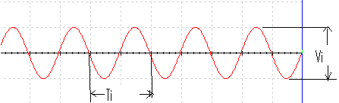
OUTPUT WAVE FORM
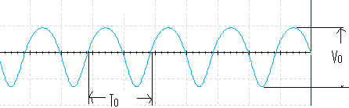

FREQUENCY RESPONSE

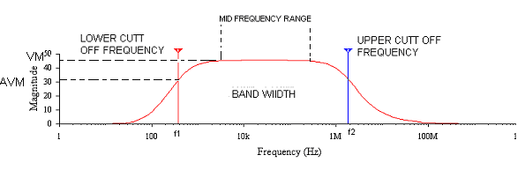
PRECAUTIONS:
- Avoid loose connections give proper input voltage

RESULT: -
- Frequency response of BJT amplifier is plotted.
- Gain = _______dB (maximum).
3. Bandwidth= f_{H}-₋f_{L} = _________Hz.

VIVA QUESTIONS:
1. What is phase difference between input and output waveforms of CE amplifier?
2. What type of biasing is used in the given circuit?
3. If the given transistor is replaced by a p-n-p, can we get output or not?
4. What is effect of emitter-bypass capacitor on frequency response?
5. What is the effect of coupling capacitor?
6. What is region of the transistor so that it is operated as an amplifier?
7. How does transistor acts as an amplifier?
8. Draw the h-parameter model of CE amplifier?
9. What type of transistor configuration is used in intermediate stages of a multistage amplifier?
10. What is Early effect?
11.For a common-emitter amplifier, the purpose of the emitter bypass capacitor is
12.For BJT amplifiers, the ________ gain typically ranges from a level just less than 1 to a level that may exceed 1000.
13. | The loaded voltage gain of an amplifier is always more than the no-load level
14.Which of the following configurations has a voltage gain of –R_{C} /r_{e}?
15.An emitter-follower amplifier has an input impedance of 107 k. The input signal is 12 . The approximate output voltage is (common-collector)
16.What is the limit of the efficiency defined by = P_{o} / P_{i}?
17. | What is r_{e} equal to in terms of h parameters?
18.What is the controlling current in a common-base configuration?
19.Which of the following techniques can be used in the sinusoidal ac analysis of transistor networks?
20.The input impedance of a BJT amplifier is purely ________ in nature and can vary from a few ________ to ________.
21.A Darlington pair amplifier has
22.What type of biasing is used in the given circuit?
23. If the given transistor is replaced by a p-n-p, can we get output or not?
24. What is effect of emitter-bypass capacitor on frequency response?
25. What is the effect of coupling capacitor?
26. What is region of the transistor so that it is operated as an amplifier?
27. How does transistor acts as an amplifier?
28. Draw the h-parameter model of CE amplifier?
29. What type of transistor configuration is used in intermediate stages of a multistage amplifier?
30. What is Early effect?
31.which amplify will amplify voltage and current.
32.define cut off frequency.
33.Give the difference between amplifier and attenuator.
34. In an NPN silicon transistor, α=0.995, I_{E}=10mA and leakage current I_{CBO}=0.5µA. Determine I_{CEO}.
35. In I_{CEO}, what does the subscript ‘CEO’ mean?
36. When the signal is applied, the ratio of change of collector current to the ratio of change of base current is called_________
37.what is the phase shift of amplified signal in CE amplifier.
38.Define current amplification factor.
39.what is the biasing rule of transistor.
40.Define bandwidth.
41.define lower cut off frequency.
42.Define upper cut off frequency.
43.What is the input impedance of CE amplifier.
44.What is the output impedance of CE amplifier.
45.What is the voltage gain of CE amplifier
46.What is the current gain of CE amplifier.
47.give the uses of coupling capacitors.
48.give the effect of bypass capacitor
49.define 3dB.
50.what is the value of dB in decimal.

Design Problems
- Plot the frequency response of CE amplifier with 50 mV Triangular I/P using BC 107.
- Plot frequency response of CE amplifier with 100 mV, R_{S} = 5K Triangular using BC 107.
- Plot frequency response of CE amplifier with 150 mV, R_{E} = 440 Ω Square using BC 107.
- Plot the frequency response of CE amplifier with C_{S} = 5 µF using SL 100.
- Plot the frequency response of CE amplifier with C_{S} = 5 µF using SL 100, V_{CC} = 5V.
- Plot the frequency response of CE amplifier with R_{B1} =22K, R_{B2} =11.2K SL 100,
- Plot the frequency response of CE amplifier with C_{E} = 200 µF using BC 107.
- Plot the frequency response of CE amplifier with C_{S} = 5 µF using PNP Transistor.
- Plot the frequency response of CE amplifier with R_{B1} =22K, R_{B2} =11.2K using PNP,
- Plot the frequency response of CE amplifier with C_{S} = 5 µF using PNP, V_{CC} = 5V.
- Plot the frequency response of CE amplifier with 10 mV Triangular I/P using BC 107.
- Plot frequency response of CE amplifier with 10 mV, R_{S} = 5K Triangular using BC 107.
- Plot frequency response of CE amplifier with 100 mV, R_{E} = 240 Ω Square using BC 107.
- Plot the frequency response of CE amplifier with C_{S} = 10 µF using SL 100.
- Plot the frequency response of CE amplifier with C_{S} = 2 µF using SL 100, V_{CC} = 5V.
- Plot the frequency response of CE amplifier with R_{B1} =20K, R_{B2} =11.2K SL 100,
- Plot the frequency response of CE amplifier with C_{E} = 100 µF using BC 107.
- Plot the frequency response of CE amplifier with C_{S} = 2 µF using PNP Transistor.
- Plot the frequency response of CE amplifier with R_{B1} =20K, R_{B2} =11.2K using PNP,
- Plot the frequency response of CE amplifier with C_{S} = 2µF using PNP, V_{CC} = 5V.
- Plot the frequency response of CE amplifier with 50 mV Triangular I/P using BC 107.
- Plot frequency response of CE amplifier with 100 mV, R_{S} = 5K Triangular using BC 107.
- Plot frequency response of CE amplifier with 150 mV, R_{E} = 440 Ω Square using BC 107.
- Plot the frequency response of CE amplifier with C_{S} = 5 µF using SL 100.
- Plot the frequency response of CE amplifier with C_{S} = 5 µF using SL 100, V_{CC} = 5V.
- Plot the frequency response of CE amplifier with R_{B1} =22K, R_{B2} =11.2K SL 100,
- Plot the frequency response of CE amplifier with C_{E} = 200 µF using BC 107.
- Plot the frequency response of CE amplifier with C_{S} = 5 µF using PNP Transistor.
- Plot the frequency response of CE amplifier with R_{B1} =22K, R_{B2} =11.2K using PNP,
- Plot the frequency response of CE amplifier with C_{S} = 5 µF using PNP, V_{CC} = 5V.

REALTIME APPLICATIONS:
Common-emitter amplifiers are also used in radio frequency circuits, for example to amplify faint signals received by an antenna In this case it is common to replace the load resistor with a tuned circuit. This may be done to limit the bandwidth to a narrow band centered around the intended operating frequency. More importantly it also allows the circuit to operate at higher frequencies as the tuned circuit can be used to resonate any inter-electrode and stray capacitances, which normally limit the frequency response. Common emitters are also commonly used as low-noise amplifiers.

EXPT NO: 10.

FREQUENCY RESPONSE OF COMMON COLLECTOR AMPLIFIER

AIM: -
- To plot frequency response of CC amplifier and calculate gain & bandwidth.

EQUIPMENTS & COMPONENTS REQUIRED:

S.No | Device | Range/Rating | Qty
1. | (a) Regulated DC supply voltage | 0-30V | 1
2 | Function generator | 1MHz | 1
2. | Dual trace CRO(oscilloscope) | 25MHz | 1
3. | BJT | BC107 OR 2N2222,BC547 | 1
4. | Connecting wires
5. | Capacitor | 10µf=2,100 µf
6. | Resistor

THEORY:
A transistor is a three terminal active device. The terminals are emitter,
base, collector. In CB configuration, the base is common to both input (emitter)
and output (collector). For normal operation, the E-B junction is forward biased
and C-B junction is reverse biased. In CB configuration, IE is +ve, IC is –ve and IB is –ve.
So, VEB=f1 (VCB,IE) and IC=f2 (VCB,IB) With an increasing the reverse collector voltage, the space-charge width at the output junction increases and the effective base width ‘W’ decreases.
This phenomenon is known as “Early effect”. Then, there will be less chance for recombination within the base region. With increase of charge gradient within the base region, the current of minority carriers injected across the emitter junction increases.The current amplification factor of CB configuration is given by, α= ΔIC/ ΔIE
In common-collector amplifier the input is given at the base and the output is taken at the emitter. In this amplifier, there is no phase inversion between input and output. The input impedance of the CC amplifier is very high and output impedance is low. The voltage gain is less than unity. Here the collector is at ac ground and the capacitors used must have a negligible
reactance at the frequency of operation. This amplifier is used for impedance matching and as a buffer amplifier. This circuit is also known as emitter follower.

CIRCUIT DIAGRAM:
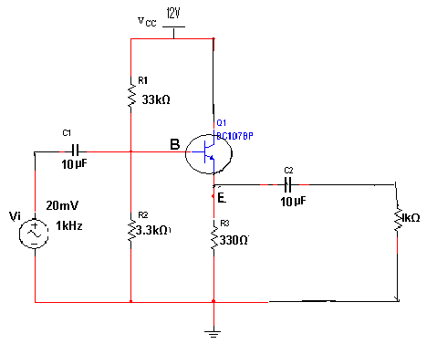

PROCEDURE: -
1. Connect the circuit according to the circuit diagram as shown in figure on breadboard.
2. Set the power supply at 12V and function generator signal amplitude (20 to 50mV) for (sine wave) 1 KHz frequency on CH-1knob to minimum position.
3. FEED the signal sine wave (20 to 50mV) to the input of CE amplifier and observe the Vi voltage on Ch-1 &output Vo voltage on Ch-2..
4. keeping the input signal unchanged select the range switch (10Hz-1MHz) in steps.
5. Note down the Vo output voltage amplitude for different frequency {15H, 25Hz, 100Hz…1MHz}
6. Tabulate the results in tabular form.
7. After calculation Av and gain in dB using semi-logarithm sheet plot the curve.

WAVEFORM:

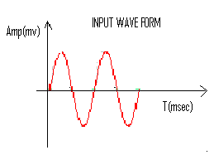
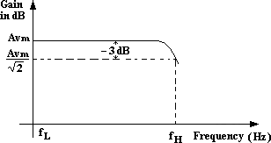
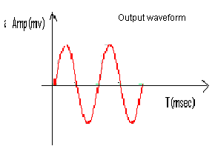
Frequency Response Curve

PRECAUTIONS:

1. The input voltage must be kept constant while taking frequency response.
2. Proper biasing voltages should be applied.

RESULT:
The voltage gain and frequency response of the CC amplifier are obtained. Also gain Bandwidth product is calculated.

VIVA QUESTIONS:
1. What are the applications of CC amplifier?
2. What is the voltage gain of CC amplifier?
3. What are the values of input and output impedances of the CC amplifier?
4. To which ground the collector terminal is connected in the circuit?
5. Identify the type of biasing used in the circuit?
6. Give the relation between α, β and γ.
7. Write the other name of CC amplifier?
8. What are the differences between CE, CB and CC?
9. When compared to CE, CC is not used for amplification. Justify youranswer?
10. What is the phase relationship between input and output in CC?
11.What is the type of capacitor used in RC coupled amplifier for a) coupling two phases
12.What is signal source used for experiment of an RC coupled amplifier and how much maximum voltage it could give
13.How do you determine AC power output in class A amplifier i.e., do you measure currentor voltage and how?
14. What are the applications of CC amplifier?
15. What is the voltage gain of CC amplifier?
16. What are the values of input and output impedances of the CC amplifier?
17. To which ground the collector terminal is connected in the circuit?
18. Identify the type of biasing used in the circuit?
19. Give the relation between α, β and γ.
20. Write the other name of CC amplifier?
21. What are the differences between CE, CB and CC?
22. When compared to CE, CC is not used for amplification. Justify youranswer?
23. What is the phase relationship between input and output in CC?
24. Give the relation between α, β and γ.
25. Write the other name of CC amplifier?
26. What are the differences between CE, CB and CC?
27. When compared to CE, CC is not used for amplification. Justify youranswer?
28. What is the phase relationship between input and output in CC?
29.What is the type of capacitor used in RC coupled amplifier for a) coupling two phases b) by pass emitter
30. Give the relation between α, β and γ?

Design Problems

1. Plot the frequency response of CC amplifier with R_{S} = 100 Ω using BC 107?
2. Plot the frequency response of CC amplifier with R_{E} = 240 Ω using BC 107?
3.Plot the frequency response of CC amplifier with R_{B1} = 10 KΩ using BC 107?
4.Plot the frequency response of CC amplifier with R_{B2} = 60 KΩ using BC 107?
5.Plot frequency response of CC amplifier triangular I/P with R_{S} = 100 Ω using BC 107?
6.Plot the frequency response of CC amplifier with R_{E} = 240 Ω using PNP Transistor?
7.Plot the frequency response of CC amplifier with R_{B2} = 60 KΩ using PNP Transistor?
8.Plot the frequency response of CC amplifier with R_{B1} = 10 KΩ using SL 100?
9.Plot frequency response of CC amplifier triangular I/P with R_{S} = 100 Ω using PNP?
10.Plot frequency response of CC amplifier Square I/P with R_{S} = 100 Ω using BC 107?
11.Plot the frequency response of CC amplifier with R_{S} = 500 Ω using BC 107?
12.Plot the frequency response of CC amplifier with R_{E} = 940 Ω using BC 107?
13.Plot the frequency response of CC amplifier with R_{B1} = 50 KΩ using BC 107?
14.Plot the frequency response of CC amplifier with R_{B2} = 66 KΩ using BC 107?
15.Plot frequency response of CC amplifier triangular I/P with R_{S} = 500 Ω using BC 107?
16.Plot the frequency response of CC amplifier with R_{E} = 940 Ω using PNP Transistor?
17.Plot the frequency response of CC amplifier with R_{B2} = 66 KΩ using PNP Transistor?
18.Plot the frequency response of CC amplifier with R_{B1} = 50 KΩ using SL 100?
19.Plot frequency response of CC amplifier triangular I/P with R_{S} = 500 Ω using PNP?
20.Plot frequency response of CC amplifier Square I/P with R_{S} = 500 Ω using BC 107

REALTIME APPLICATIONS:
The low output impedance allows a source with a large output impedance to drive a small load impedance; it functions as a voltage buffer. In other words, the circuit has current gain (which depends largely on the h_{FE} of the transistor) instead of voltage gain. A small change to the input current results in much larger change in the output current supplied to the output load.
One aspect of buffer action is transformation of impedances. For example, the Thévenin resistance of a combination of a voltage follower driven by a voltage source with high Thévenin resistance is reduced to only the output resistance of the voltage follower (a small resistance). That resistance reduction makes the combination a more ideal voltage source. Conversely, a voltage follower inserted between a small load resistance and a driving stage presents a large load to the driving stage—an advantage in coupling a voltage signal to a small load.
This configuration is commonly used in the output stages of class-B and class-AB amplifiers. The base circuit is modified to operate the transistor in class-B or AB mode. In class-A mode, sometimes an active current source is used instead of R_{E}(Fig. 4) to improve linearity and/or efficiency.^{[1]}

EXPT NO: 11.

FREQUENCY RESPONSE OF COMMON SOURCE FET AMPLIFIER

AIM: -
- To plot frequency response of CS amplifier (common source) and calculate gain & bandwidth.

EQUIPMENTS & COMPONENTS REQUIRED:

S.No | Device | Range/Rating | Qty
1. | (a) Regulated DC supply voltage | 0-30V | 1
2 | Function generator | 1MHz | 1
2. | Dual trace CRO(oscilloscope) | 25MHz | 1
3. | FET | BFW10/11 or BF245 | 1
4. | Connecting wires
5. | Capacitor | 10µf=2,100 µf
6. | Resistor | 1K,4.7K,1M,1K

THEORY:
A field-effect transistor (FET) is a type of transistor commonly used for weak-signal amplification (for example, for amplifying wireless (signals). The device can amplify analog or digital signals. It can also switch DC or function as an oscillator. In the FET, current flows along a semiconductor path called the channel. At one end of the channel, there is an electrode called the source. At the other end of the channel, there is an electrode called the drain. The physical
diameter of the channel is fixed, but its effective electrical diameter can be varied by the application of a voltage to a control electrode called the gate. Field-effect transistors exist in two major classifications. These are known as the junction FET (JFET) and the metal-oxide- semiconductor FET (MOSFET). The junction FET has a channel consisting of N-type semiconductor (N channel) or P-type semiconductor (P-channel) material; the gate is made of the opposite semiconductor type. In P-type material, electric charges are carried mainly in the form of electron deficiencies called holes. In N-type material, the charge carriers are primarily electrons. In a JFET, the junction is the boundary between the channel and the gate. Normally, this P-N junction is reverse-biased (a DC voltage is applied to it) so that no current flows between the channel and the gate. However, under some conditions there is a small current through the junction during part of the input signal cycle. The FET has some advantages
and some disadvantages relative to the bipolar transistor. Field-effect transistors are preferred for weak-signal work, for example in wireless, communications and broadcast receivers. They are also preferred in circuits and systems requiring high impedance. The FET is not, in general, used for high-power amplification, such as is required in large wireless communications
and broadcast transmitters. Field-effect transistors are fabricated onto silicon integrated circuit (IC) chips. A single IC can contain many thousands of FETs, along with other components
such as resistors, capacitors, and diodes.

CIRCUIT DIAGRAM:

PROCEDURE: -
1. Connect the circuit according to the circuit diagram as shown in figure on breadboard.
2. Set the power supply at 12V and function generator signal amplitude (20 to 50mV) for (sine wave) 1 KHz frequency on CH-1knob to minimum position.
3. FEED the signal sine wave (20 to 50mV) to the input of CE amplifier and observe the Vi voltage on Ch-1 &output Vo voltage on Ch-2..
4. keeping the input signal unchanged select the range switch (10Hz-1MHz) in steps.
5. Note down the Vo output voltage amplitude for different frequency {15H, 25Hz, 100Hz…1MHz}
6. Tabulate the results in tabular form.
7. After calculation Av and gain in dB using semi-logarithm sheet plot the curve.

PRECAUTIONS:
1. Avoid loose connections and give proper input Voltage

TABULAR COLUMN: Input = 50mV
Frequency (in Hz) | Output Voltage (V_{o}) | Gain A_{v}=V_{o}/V_{i} | Gain(in dB) =20log₁₀(V_{o}/V_{i})
10
50
100
1K
10k
50K,100K
200k,500K
1M
EXPECTED GRAPH:

RESULT: -
1. Frequency response of FET Common source amplifier is plotted.
2. Gain = _______dB (maximum).
3. Bandwidth= f_{H}-₋f_{L} = _________Hz.

VIVA QUESTIONS:
- What is Miller effect on common source amplifier?
- What is the purpose of source resistor and gate resistor?
- What is swamping resistor
- What is the purpose of swamping resistor in common source amplifier
- FET is a liner or non-linear device. And justify your answer
- What is square law and give an example for a square law device
- A common-gate amplifier is similar in configuration to which BJT amplifier?
- The theoretical efficiency of a class D amplifier is
- A common-source amplifier is similar in configuration to which BJT amplifier?
10.A BJT is a ________-controlled device.
11. A common-drain amplifier is similar in configuration to which BJT amplifier?
12. For what value of I_{D} is g_{m} equal to 0.5 g_{m0}?
13. Where do you get the level of g_{m} and r_{d} for an FET transistor?
14.The class D amplifier uses what type of transistors?
15. What is the input resistance (R_{in(source)}) of a common-gate amplifier?
16. Which of the following is a required condition to simplify the equations for Z_{o} and A_{v} for the self-bias configuration?
17. The steeper the slope of the I_{D} versus V_{GS} curve, the ________ the level of g_{m}
18. What is the typical value for the input impedance Z_{i} for JFETs?
19. MOSFET digital switching is used to produce which digital gates?
20. Which type of FETs can operate with a gate-to-source Q-point value of 0 V?
21. What is Miller effect on common source amplifier?
22.What is the purpose of source resistor and gate resistor?
23.What is swamping resistor
24.What is the purpose of swamping resistor in common source amplifier
25. FET is a liner or non-linear device. And justify your answer
26.What is square law and give an example for a square law device
27.A common-gate amplifier is similar in configuration to which BJT amplifier?
28.The theoretical efficiency of a class D amplifier is
29.A common-source amplifier is similar in configuration to which BJT amplifier?
30.A BJT is a ________-controlled device
31.A common-gate amplifier is similar in configuration to which BJT amplifier.
32.A common drain –amplifier is configuration to which BJT amplifier.
33. 33Use the following equation to calculate g_{m} for a JFET having I_{DSS} = 10 mA, V_{P} = –5 V, and V_{GSQ} = –2.5 V.
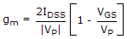
- Where do you get the level of g_{m} and r_{d} for an FET transistor?
34.Where do you get the level of g_{m} and r_{d} for an FET transistor?
35.What is (are) the function(s) of the coupling capacitors C₁ and C₂ in an FET circuit?
36. What is the input resistance (R_{in(source)}) of a common-gate amplifier?
37. What is the ________º phase inversion between gate and source in a source follower.
38. What is the typical value for the input impedance Z_{i} for JFETs?
39. Which type of FETs can operate with a gate-to-source Q-point value of 0 V?
40. FET amplifiers provide ________.
41. What is the range of g_{m} for JFETs?
42. The gate-to-source voltage V_{GS} of a(n) ________ must be larger than the threshold V v_{GS(Th)} for the transistor to conduct.
43The isolation between input and output circuits in the ac equivalent circuit is lost in a ________ configuration.
44..What happens to the transconductance as the Q-point moves from V_{p} to I_{DSS}

45.The input and output signals are in phase in a ________ configuration.

.
  46.List the only parameter that is different between voltage-divider and fixed-bias configurations.
  47.Define Transconductance
  48. The ________ configuration has an input impedance, which is other than R_{G}.
  49. The ________ configuration has the distinct disadvantage of requiring two dc voltage sources.
  50. A field-effect transistor amplifier provides excellent voltage gain with the added feature of a ________ input impedance.
  .

Design Problems
- Plot the frequency and amplitude response of FET BFW 10 amplifier with C₁ = 5 µF.
- Plot the frequency response of FET BFW 10 amplifier with C₂ = 5 µF with triangular i/p.
- Plot the amplitude response of FET BFW 10 amplifier with R_{G1} = 4.1 K.
- Plot the amplitude response of FET BFW 10 amplifier with R_{G2} = 9.4 K triangular i/p.
- Plot frequency response of BFW 10 amplifier R_{G1} = 4.1 K, R_{G2} = 9.4 K with square i/p.
- Plot the frequency and amplitude response of FET BFW 11 amplifier with C₁ = 5 µF.
- Plot the frequency response of P Channel JFET amplifier with C₂ = 5 µF, triangular i/p.
- Plot the amplitude response of FET BFW 11 amplifier with R_{G1} = 4.1 K.
- Plot the amplitude response of P Channel JFET amplifier with R_{G2} = 9.4 K triangular i/p.
- Plot frequency response of P Channel JFET R_{G1} = 4.1 K, R_{G2} = 9.4 K with square i/p.
- Plot the frequency and amplitude response of FET BFW 10 amplifier with C₁ = 10 µF.
- Plot the frequency response of FET BFW 10 amplifier with C₂ = 2 µF with triangular i/p.
- Plot the amplitude response of FET BFW 10 amplifier with R_{G1} = 2.1 K.
- Plot the amplitude response of FET BFW 10 amplifier with R_{G2} = 5.4 K triangular i/p.
- Plot frequency response of BFW 10 amplifier R_{G1} = 2.1 K, R_{G2} = 2.4 K with square i/p.
- Plot the frequency and amplitude response of FET BFW 11 amplifier with C₁ = 2 µF.
- Plot the frequency response of P Channel JFET amplifier with C₂ = 2 µF, triangular i/p.
- Plot the amplitude response of FET BFW 11 amplifier with R_{G1} = 2.1 K.
- Plot the amplitude response of P Channel JFET amplifier with R_{G2} = 2.4 K triangular i/p.
- Plot frequency response of P Channel JFET R_{G1} = 2.1 K, R_{G2} = 9.4 K with square i/p.
- Plot the frequency and amplitude response of FET BFW 10 amplifier with C₁ = 5 µF.
- Plot the frequency response of FET BFW 10 amplifier with C₂ = 5 µF with triangular i/p.
- Plot the amplitude response of FET BFW 10 amplifier with R_{G1} = 4.1 K.
- Plot the amplitude response of FET BFW 10 amplifier with R_{G2} = 9.4 K triangular i/p.
- Plot frequency response of BFW 10 amplifier R_{G1} = 4.1 K, R_{G2} = 9.4 K with square i/p.
- Plot the frequency and amplitude response of FET BFW 11 amplifier with C₁ = 5 µF.
- Plot the frequency response of P Channel JFET amplifier with C₂ = 5 µF, triangular i/p.
- Plot the amplitude response of FET BFW 11 amplifier with R_{G1} = 4.1 K.
- Plot the amplitude response of P Channel JFET amplifier with R_{G2} = 9.4 K triangular i/p.
30.Plot frequency response of P Channel JFET R_{G1} = 4.1 K, R_{G2} = 9.4 K with square i/p

REALTIME APPLICATIONS:
The common-source (CS) amplifier may be viewed as a transconductance amplifier or as a voltage amplifier. (See classification of amplifiers). As a transconductance amplifier, the input voltage is seen as modulating the current going to the load. As a voltage amplifier, input voltage modulates the amount of current flowing through the FET, changing the voltage across the output resistance according to Ohm's law. However, the FET device's output resistance typically is not high enough for a reasonable transconductance amplifier (ideally infinite), nor low enough for a decent voltage amplifier (ideally zero). Another major drawback is the amplifier's limited high-frequency response. Therefore, in practice the output often is routed through either a voltage follower (common-drain or CD stage), or a current follower (common-gate or CG stage), to obtain more favorable output and frequency characteristics. The CS–CG combination is called a cascode amplifie

EXPT NO: 12

SCR CHARACTERISTICS

AIM: -
- To study the characteristics of SCR

EQUIPMENTS & COMPONENTS REQUIRED:

S.No | Device | Range/Rating | Qty
1. | (a) Regulated DC supply voltage | 0-30V | 1
2. | Voltmeter | ,0-20V | 2
3. | Ammeter | 0-10mA or 200mA | 1
4. | Connecting wires
5. | SCR | TYN604 or 616
6. | Resistor | lK,10K

THEORY:
A silicon-controlled rectifier (or semiconductor-controlled rectifier) is a four-layer solid state current controlling device. The name "silicon controlled rectifier" is General Electric's trade name for a type of thyristor. The SCR was developed by a team of power engineers led by Gordon Hall and commercialized by Frank W. "Bill" Gutzwiller in 1957. The . Silicon Control Rectifier (SCR) consists of four layers of semiconductors, which form NPNP or PNP structures. It has three junctions, labeled J1, J2, and J3 and three terminals. The anode terminal of an SCR is connected to the P-Type material of a PNPN structure, and the cathode terminal is connected to the N-Type layer, while the gate of the Silicon Control Rectifier SCR is connected to the P-Type material nearest to the cathode. SCRs are unidirectional devices (i.e. can conduct current only in one direction) as opposed to TRIACs which are bidirectional (i.e. current can flow through them in either direction). SCRs can be triggered normally only by currents going into the gate as opposed to TRIACs which can be triggered normally by either a positive or a negative current applied to its gate electrode.
SCRs are mainly used in devices where the control of high power, possibly coupled with high voltage, is demanded. Their operation (it can switch large current on and off) makes them suitable for use in medium to high-voltage AC power control applications, such as lamp dimming, regulators and motor control. SCRs and similar devices are used for rectification of high power AC in high-voltage direct current power transmission. They are also used in the control of welding machines, mainly MTAW (Metal Tungsten Arc Welding) and GTAW (Gas Tungsten Arc Welding) process.

CIRCUIT DIAGRAM:
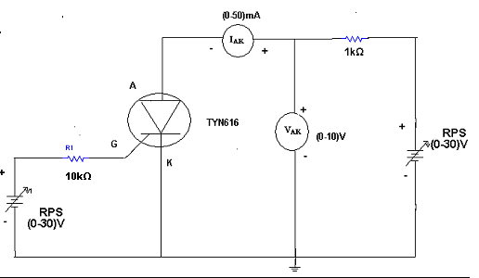
PROCEDURE: -
1. Connect the circuit according to the circuit diagram as shown in figure.
2. Keep the power supply knob to minimum position.
3. Set V_{AA starting} from zero gradually until the current begins to rise and the voltage V suddenly drops to low value.
4. Note the reading V & I just before and immediately after the firing on the SCR.
5. Repeat step 3 for various values of IG say 10mA & 8mA
6. Tabulate the reading in the table. Note down the latching and holding currents from the plot

OBSERVATION
V_{AK}(V) | I_{AK} ( mA)

EXPECTED WAVEFORM:
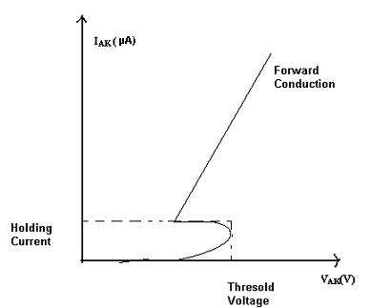

RESULT: SCR Characteristics are observed

VIVA QUESTIONS:
- How many junctions are there in SCR?
- Name few applications of SCR?
- Name the types of SCR?
- IS SCR a unidirectional device?
- What do you mean by holding current and holding voltage?
- What is meant by the term break over voltage?
- What is the usual method of switching off and SCR?
- What is Thyristor?
- What are diac and tric?
- What does latching of an SCR mean?
- What is asymmetrical SCR?
- Why is Peak Reverse Voltage Important?
- What are the applications of SCR?
- What is the difference between SCR and TRIAC?
- What is an SCR?
- What are the difference between transistor and SCR?
- Explain latching current and holding current of the thyristor
- What are the advantages of MOSFET’s over BJT’s?
- Why pulsed gate drive is used for SCR?
- Define the delay angle of phase-controlled rectifier.
- Why is power factor of semi converter better than full converter?
- What are the differences between freewheeling diode and feedback diode?
- What is inverting operation of the converter?
- What are control strategies of chopper?
- Explain the use of step-up chopper.
- What is four quadrant chopper?
- Name few applications of SCR?
- Name the types of SCR?
- IS SCR a unidirectional device?
- What do you mean by holding current and holding voltage?

31.What is a Thyristor or SCR?

32 Draw the two transistor model or analogy of SCR

33. Define Holding current and Latching current?

34 What is the Turn ON processes of SCR?

35 What is Forward Voltage Triggering?

36What is Thermal or Temperature Triggering?

37What is dv/dt triggering?

38What is Gate triggering?

39What are the Gate control methods?

40What are the advantages of Gate Turn ON process?
42.How many terminals of SCR and their names
43.Why is it called Silicon controlled rectifier
44.What is rectification
45.How can SCR control the rectification
46.How to trigger SCR
47.What are operating modes or operating regions of SCR
48.What is forward blocking mode. Explain?
49.What is forward conduction mode. Explain?
50.What is reverse blocking mode. Explain

Design Problems
- Plot the volt ampere characteristics of SCR 2N46 with R_{E} = 500 Ω.
- Plot the volt ampere characteristics of SCR 2N46 with R_{B2} = 500 Ω.
- Plot the volt ampere characteristics of SCR 2N46 with R_{B1} = 940 Ω.
- Plot the volt ampere characteristics of SCR 2N46 with R_{E} = R_{B2} = 500 Ω.
- Plot thevolt ampere characteristics of SCR 2N46 with R_{E} = R_{B2} = 1 K Ω and R_{B1} = 500 Ω.
- Draw the volt ampere characteristics of SCR 2N47 with R_{E} = 500 Ω.
- Draw the volt ampere characteristics of SCR 2N47 with R_{B2} = 500 Ω.
- Draw the volt ampere characteristics of SCR2N47 with R_{B1} = 940 Ω.
- Draw the volt ampere characteristics of SCR2N47 with R_{E} = R_{B2} = 1000 Ω.
- Draw the volt ampere characteristics of SCR2N47 with R_{B1} = R_{B2} = 1 K Ω and R_{E} =0.5K.
- Plot the volt ampere characteristics of SCR2N46 with R_{E} = 200 Ω.
- Plot the volt ampere characteristics of SCR 2N46 with R_{B2} = 200 Ω.
- Plot the volt ampere characteristics of SCR 2N46 with R_{B1} = 140 Ω.
- Plot the volt ampere characteristics of SCR 2N46 with R_{E} = R_{B2} = 10 Ω.
- Plot the volt ampere characteristics ofSCR 2N46 with R_{E} = R_{B2} = 1 K Ω and R_{B1} = 10 Ω.
- Draw the volt ampere characteristics of SCR2N47 with R_{E} = 200 Ω.
- Draw the volt ampere characteristics of SCR 2N47 with R_{B2} = 200 Ω.
- Draw the volt ampere characteristics of SCR 2N47 with R_{B1} = 140 Ω.
- Draw the volt ampere characteristics of SCR2N47 with R_{E} = R_{B2} = 100Ω.
- Draw the volt ampere characteristics of SCR 2N47 with R_{B1} = R_{B2} = 1 0 Ω and R_{E} =1K.
- Plot the volt ampere characteristics of SCR 2N46 with R_{E} = 500 Ω.
- Plot the volt ampere characteristics of SCR 2N46 with R_{B2} = 500 Ω.
- Plot the volt ampere characteristics of SCR 2N46 with R_{B1} = 940 Ω.
- Plot the volt ampere characteristics of SCR 2N46 with R_{E} = R_{B2} = 500 Ω.
- Plot thevolt ampere characteristics of SCR 2N46 with R_{E} = R_{B2} = 1 K Ω and R_{B1} = 500 Ω.
- Draw the volt ampere characteristics of SCR 2N47 with R_{E} = 500 Ω.
- Draw the volt ampere characteristics of SCR 2N47 with R_{B2} = 500 Ω.
- Draw the volt ampere characteristics of SCR2N47 with R_{B1} = 940 Ω.
- Draw the volt ampere characteristics of SCR2N47 with R_{E} = R_{B2} = 1000 Ω.
- Draw the volt ampere characteristics of SCR2N47 with R_{B1} = R_{B2} = 1 K Ω and R_{E} =0.5K.

REALTIME APPLICATIONS:
SCRs are mainly used in devices where the control of high power, possibly coupled with high voltage, is demanded. Their operation makes them suitable for use in medium- to high-voltage AC power control applications, such as lamp dimming, regulators and motor control.
SCRs and similar devices are used for rectification of high-power AC in high-voltage direct-current power transmission. They are also used in the control of welding machines, mainly MTAW (metal tungsten arc welding) and GTAW (gas tungsten arc welding) processes.

EXPT NO: 13.

UJT CHARACTERISTICS

AIM: -
- To study the characteristics of UJT

EQUIPMENTS & COMPONENTS REQUIRED:

S.No | Device | Range/Rating | Qty
1. | (a) Regulated DC supply voltage | 0-30V | 1
2. | Voltmeter | ,0-20V | 2
3. | Ammeter | 0-10mA or 200mA | 1
4. | Connecting wires
5. | UJT | 2N2646 | 1
6. | Resistor | 330Ω,470Ω,1k,10k | 1each

Theory:
A unijunction transistor (UJT) is a three-lead electronic semiconductor device with only one junction that acts exclusively as an electrically controlled switch. The UJT is not used as a linear amplifier. It is used in free-running oscillators, synchronized or triggered oscillators, and pulse generation circuits at low to moderate frequencies (hundreds of kilohertz). It is widely used in the triggering circuits for silicon controlled rectifiers. The low cost per unit, combined with its unique characteristic, have warranted its use in a wide variety of applications like oscillators, pulse generators, saw-tooth generators, triggering circuits, phase control, timing circuits, and voltage- or current-regulated supplies. The original unijunction transistor types are now considered obsolete; but a later multi-layer device, the "programmable unijunction transistor", is still widely available.
The UJT has three terminals: an emitter (E) and two bases (B₁ and B₂) and so is sometimes called a "double-base diode". If no potential difference exists between its emitter and either of its base leads, an extremely small amount of current flows from B₂ to B₁. On the other hand, if an adequately large voltage relative to its base leads, known as the trigger voltage, is applied to its emitter, then a very large current will flow from its emitter and join the current flowing from B₂ to B₁, which would create a larger B₁ output current.
The base is formed by lightly doped n-type bar of silicon. Two ohmic contacts B₁ and B₂ are attached at its ends. The emitter is of p-type and it is heavily doped; this single PN junction gives the device its name. The resistance between B1 and B2 when the emitter is open-circuit is called interbase resistance. The emitter junction is usually located closer to base-2 (B2) than base-1 (B1) so that the device is not symmetrical, because symmetrical unit does not provide optimum electrical characteristics for most of the applications.

CIRCUIT DIAGRAM:
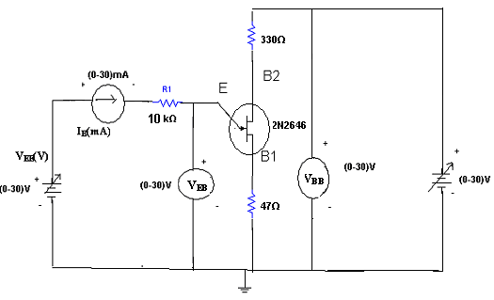
PROCEDURE: -
1. Connect the circuit according to the circuit diagram as shown in figure.
2. Keep the power supply knob to minimum position.
3. Set the VBB voltage at 5V.
4. Vary the VEB voltage and note down the Ie emitter current in the table.
5. Repeat the step 4 for VBB 10v
6. Plot the graph

EXPECTED GRAPH:
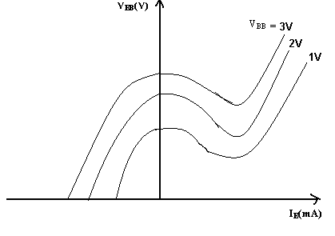

OBSEVATIONS:
V_{BB}=2V |  | V_{BB}=3V
V_{EB}(V) | I_{E}(mA) | V_{EB}(V) | I_{E}(mA)
CALCULATIONS:
V_{P} = ηV_{BB} + V_{D}
η = (V_{P}-V_{D}) / V_{BB}
η = (η1 + η₂ + η₃) / 3
RESULT: The characteristics of UJT are observed and the value of Intrinsic Stand-Off Ratio is calculated.

VIVA QUESTIONS
- What is the symbol of UJT?
- Draw the equivalent circuit of UJT?
- What are the applications of UJT?
- Formula for the intrinsic standoff ratio?
- What does it indicates the direction of arrow in the UJT?
- What is the difference between FET and UJT?
- Is UJT is used an oscillator? Why?
- What is the Resistance between B₁ and B₂ is called as?
- What is its value of resistance between B₁ and B_{2?}
- Draw the characteristics of UJT?
11. Define latching current.
12. Define holding current
13. Define drain resistance
14. .Define inter-base resistance
15. What is amplification factor
16. W hat is the other name of UJT?
17. Derive intrinsic stand off ratio.
18. Draw the equivalent circuit of UJT.
19.Write the features of UJT.
20.What is the difference between UJT and FET?
21.What is a UJT?
22. What is relaxation oscillator?
23.What are the applications of UJT?
24.What is the symbol of UJT?
25.Draw the equivalent circuit of UJT?
26.What are the applications of UJT?
27.Formula for the intrinsic standoff ratio?
28.What does it indicates the direction of arrow in the UJT?
29.What is the difference between FET and UJT?
30.Is UJT is used an oscillator? Why
31.What is a relaxation oscillator?
32.List the useful applications of a relaxation oscillator
33.What is meant by intrinsic stand off ratio of an UJT?
34. Why UJT is called as negative resistance device? When the negative resistance exists in UJT characteristics.
35.Draw the equivalent circuit of an UJT
36. What are Peak point and valley point for an UJT?
37.Write formula for Peak voltage.
38.What are the applications of UJT?
39. What is the importance of intrinsic stand-off ratio?
40. Why does negative resistance region appears in UJT?
41 .What is the doping profile of UJT?
42 .Is there any break down region in UJT?
43. Mention any application of UJT relaxation oscillator
44. What is intrinsic standoff ratio?
45What is a relaxation oscillator?
46.Why Ujt is called as negative resistance device?
47.What is the main difference between the Ujt and BJT?
48.What is valley point of Ujt?
49.What is Ujt triggering circuit?
50. What is a relaxation oscillator used for?

Design Problems
- Plot the volt ampere characteristics of UJT 2N46 with R_{E} = 500 Ω.
- Plot the volt ampere characteristics of UJT 2N46 with R_{B2} = 500 Ω.
- Plot the volt ampere characteristics of UJT 2N46 with R_{B1} = 940 Ω.
- Plot the volt ampere characteristics of UJT 2N46 with R_{E} = R_{B2} = 500 Ω.
- Plot the volt ampere characteristics of UJT 2N46 with R_{E} = R_{B2} = 1 K Ω and R_{B1} = 500 Ω.
- Draw the volt ampere characteristics of UJT 2N47 with R_{E} = 500 Ω.
- Draw the volt ampere characteristics of UJT 2N47 with R_{B2} = 500 Ω.
- Draw the volt ampere characteristics of UJT 2N47 with R_{B1} = 940 Ω.
- Draw the volt ampere characteristics of UJT 2N47 with R_{E} = R_{B2} = 1000 Ω.
- Draw the volt ampere characteristics of UJT 2N47 with R_{B1} = R_{B2} = 1 K Ω and R_{E} =0.5K.
- Plot the volt ampere characteristics of UJT 2N46 with R_{E} = 200 Ω.
- Plot the volt ampere characteristics of UJT 2N46 with R_{B2} = 200 Ω.
- Plot the volt ampere characteristics of UJT 2N46 with R_{B1} = 140 Ω.
- Plot the volt ampere characteristics of UJT 2N46 with R_{E} = R_{B2} = 200 Ω.
- Plot the volt ampere characteristics of UJT 2N46 with R_{E} = R_{B2} = 1 0 Ω and R_{B1} = 200 Ω.
- Draw the volt ampere characteristics of UJT 2N47 with R_{E} = 200 Ω.
- Draw the volt ampere characteristics of UJT 2N47 with R_{B2} = 200 Ω.
- Draw the volt ampere characteristics of UJT 2N47 with R_{B1} = 140 Ω.
- Draw the volt ampere characteristics of UJT 2N47 with R_{E} = R_{B2} = 200Ω.
- Draw the volt ampere characteristics of UJT 2N47 with R_{B1} = R_{B2} = 1 0 Ω and R_{E} =1K.
- Plot the volt ampere characteristics of UJT 2N46 with R_{E} = 500 Ω.
- Plot the volt ampere characteristics of UJT 2N46 with R_{B2} = 500 Ω.
- Plot the volt ampere characteristics of UJT 2N46 with R_{B1} = 940 Ω.
- Plot the volt ampere characteristics of UJT 2N46 with R_{E} = R_{B2} = 500 Ω.
- Plot the volt ampere characteristics of UJT 2N46 with R_{E} = R_{B2} = 1 K Ω and R_{B1} = 500 Ω.
- Draw the volt ampere characteristics of UJT 2N47 with R_{E} = 500 Ω.
- Draw the volt ampere characteristics of UJT 2N47 with R_{B2} = 500 Ω.
- Draw the volt ampere characteristics of UJT 2N47 with R_{B1} = 940 Ω.
- Draw the volt ampere characteristics of UJT 2N47 with R_{E} = R_{B2} = 1000 Ω.
- Draw the volt ampere characteristics of UJT 2N47 with R_{B1} = R_{B2} = 1 K Ω and R_{E} =0.5K.

REALTIME APPLICATIONS:
Injunction transistor circuits were popular in hobbyist electronics circuits in the 1960s and 1970s because they allowed simple oscillators to be built using just one active device. For example, they were used for relaxation oscillators in variable-rate strobe lights.^{[3]} Later, as integrated circuits became more popular, oscillators such as the 555 timer ICbecame more commonly used.

